
School of Computing, Creative Technology and Engineering

Student ID | 77466805
Student Name | Quincy Dahal
Module Name & CRN | Applied Machine Learning - 18910
Level | Level 5 (Sem -II)
Assessment Name & Part No. | Coursework Part-2
Project Title | Default Predictions Using Various Models
Date of Submission | 09/05/2025
Course | Computing
Academic Year | 2025

Contents
Section 1 : Introduction 5
Summary of Part-1 Implementation 5
Key Takeaways From Part-1 5
Major Findings From Part-1 5
Some Plots 6
Figure 1 : Correlation Matrix Of Numeric Numbers 6
Figure 2: Missing Data Pattern 7
Figure 3: Percentage of Missing Values per Column 8
Figure 4: Comparisons of Variables Before and After Winsorization 9
Section 2: Modelling Phase 10
1. Logistic Regression 10
a. Step By Step Implementation in R 10
i. Data Partitioning 10
ii. Model Training 10
iii. Prediction and Testing 10
iv. Evaluation 11
v. Plot 12
b. Model Improvement 13
i. Description of What Was Changed 13
ii. Why Were These Changes Made? 14
iii. New Results After Improvement 14
iv. Plot 15
2. KNN 16
a. Step By Step Implementation in R 16
i. Data Partitioning 16
ii. Pre-Processing (Normalization for KNN) 16
iii. Model Training 17
iv. Prediction and Testing 17
v. Evaluation 18
vi. Plot 19
b. Model Improvement 20
i. Description of What Was Changed 20
ii. Why Were These Changes Made? 21
iii. New Results After Improvement 21
iv. Plot 22
3. Naïve Bayes(NB) 23
a. Step By Step Implementation 23
i. Data Partitioning 23
ii. Model Training 23
iii. Prediction and Testing 24
iv. Evaluation 24
v. Plot 25
b. Model Improvement 26
i. Description of What Was Changed? 26
ii. Why Were These Changes Made? 27
iii. Model Selection Process 27
iv. Result After Improvement 28
v. Plot 29
4. Decision Tree (DT) 30
a. Step by Step Implementation in R 30
i. Data Partitioning 30
ii. Model Training 30
iii. Prediction and Testing 30
iv. Evaluation 31
v. Plots 32
b. Model Improvement 33
i. Description Of What Was Changed 33
ii. Why Were These Changes Made? 33
iii. New Results After Improvement 34
iv. Plots 34
5. Random Forest (RF) 36
a. Step By Step Implementation in R 36
i. Data Partitioning 36
ii. Model Training 36
iii. Prediction and Testing 36
iv. Evaluation 37
v. Plot 38
b. Model Improvement 39
i. Description of What Was Changed 39
ii. Why Were These Changes Made? 40
iii. New Results After Improvement 40
iv. Plot 41
6. Multimodel (Naïve Bayes + Random Forest) 42
a. Step By Step Implementation in R 42
i. Data Partitioning 42
ii. Smote Application 42
iii. Model Training 42
iv. Ensemble Prediction 43
v. Evaluation 43
vi. Plot 44
b. Interpretation 44
Section 3 : Model Results 45
a. Before Tuning 45
b. After Tuning 46
Section 4 : Model Performance Analysis 47
a. Pre -Tuning Performance 47
b. Post – Tuning Performance 47
Section 5 : Best Model Selection and Interpretation 48
Section 6 : Conclusion 48
Bibliography 49

Section 1 : Introduction

The first part of the project work included preparing the credit card default dataset for analysis and modelling in Part-1. The goal was to clean the data and make it ready for building accurate prediction models.

Summary of Part-1 Implementation

In Part-1, the dataset was first loaded and reviewed. Unnecessary columns, such as ID numbers, were removed because they didn’t help with prediction. Columns with constant values , meaning they showed the same number for every row, were also deleted since they didn’t add useful information.

Missing Values were found in some parts of the data. The “MICE (Multiple Imputation by Chained Equations)” method completed the missing value analysis by using additional available data to estimate the missing values rather than deleting the affected rows.

Some values in the data were extremely high or low compared to the rest. “Winsorization” eliminated outlier data by substituting them with more appropriate values.

A check for multicollinearity was done to find the columns that were too similar to others. When two columns gave almost the same information, one was removed to make the dataset more efficient.

Finally, all numeric values were scaled using “z- score normalization” so that they followed the same range. The performance of machine learning models gets simpler because of this standardization process.

Key Takeaways From Part-1

- The initial dataset included information that was both unnecessary and duplicated.
- MICE imputation method effectively dealt with missing data patterns while maintaining all original data points.
- The analysis adjusted outliers to minimize their effect on the results.
- The analysis identified columns with high correlation which were then removed to prevent confusion.
- The normalization process standardized all values to achieve improved performance.

Major Findings From Part-1

- A total of five columns with high correlations were eliminated from the dataset.
- The analysis successfully managed all missing data points.
- The data quality improved through the correlations of extreme values in the dataset.
- The data collection process has resulted in a prepared dataset which can be used to construct classification models.

Some Plots

Figure 1 : Correlation Matrix Of Numeric Numbers
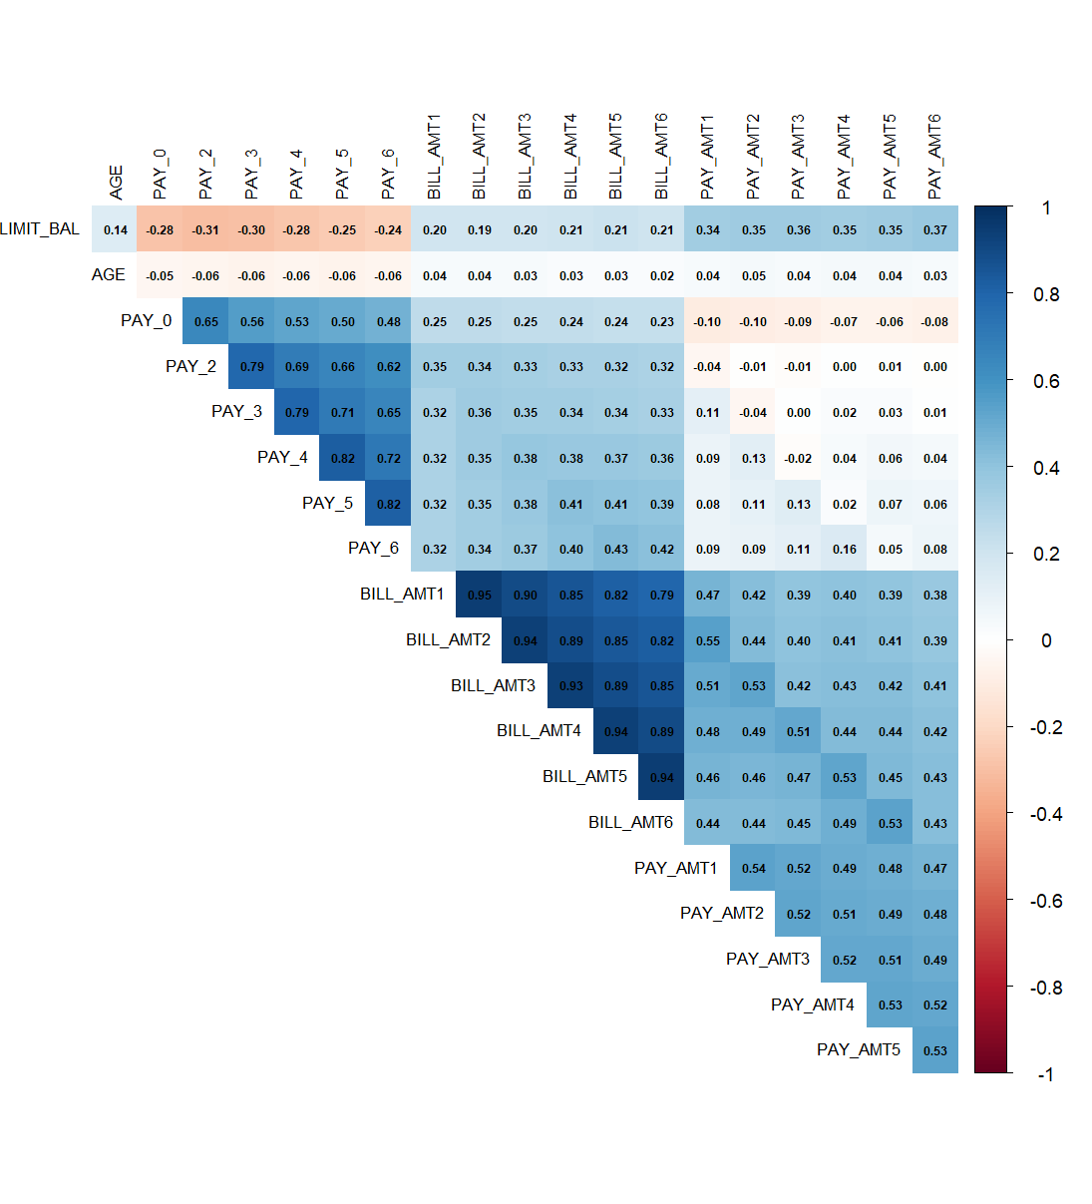

The plot demonstrates the numerical variable correlation relationships between each pair. The analysis removed variables with correlation values exceeding 0.8 to minimize multicollinearity between variables.

Figure 2: Missing Data Pattern
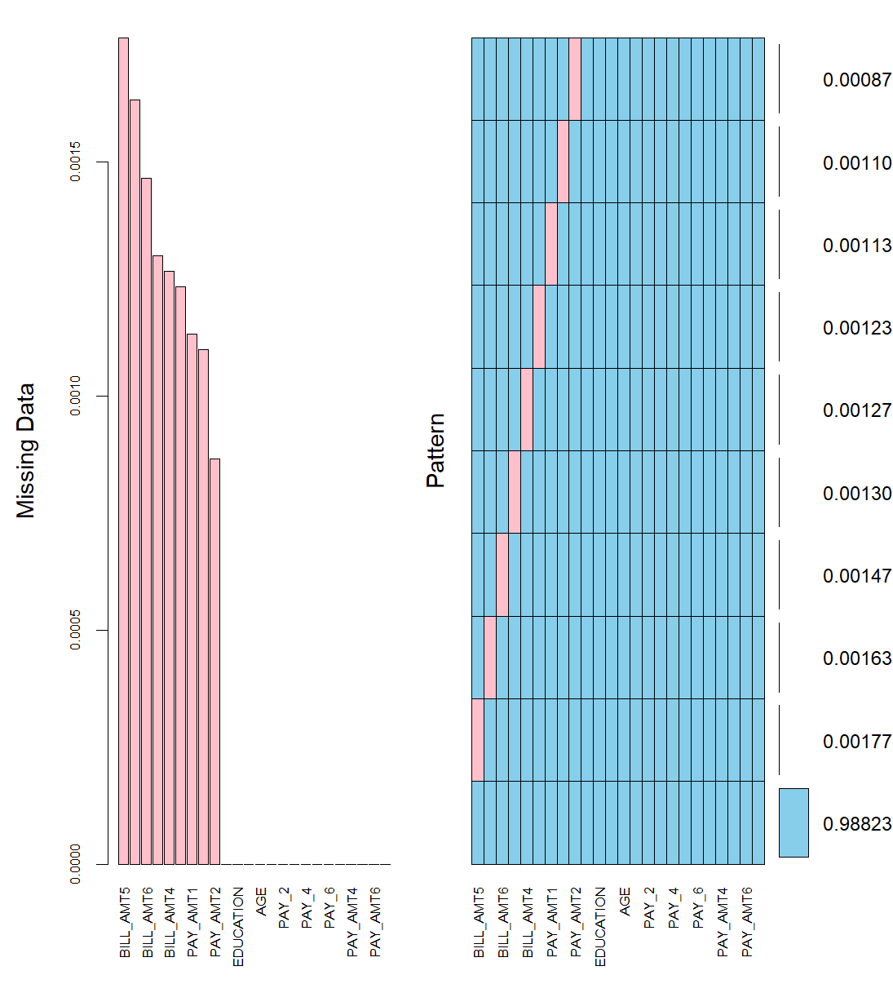

The visualization demonstrates how missing values were spread across features before implementing the imputation steps.

Figure 3: Percentage of Missing Values per Column
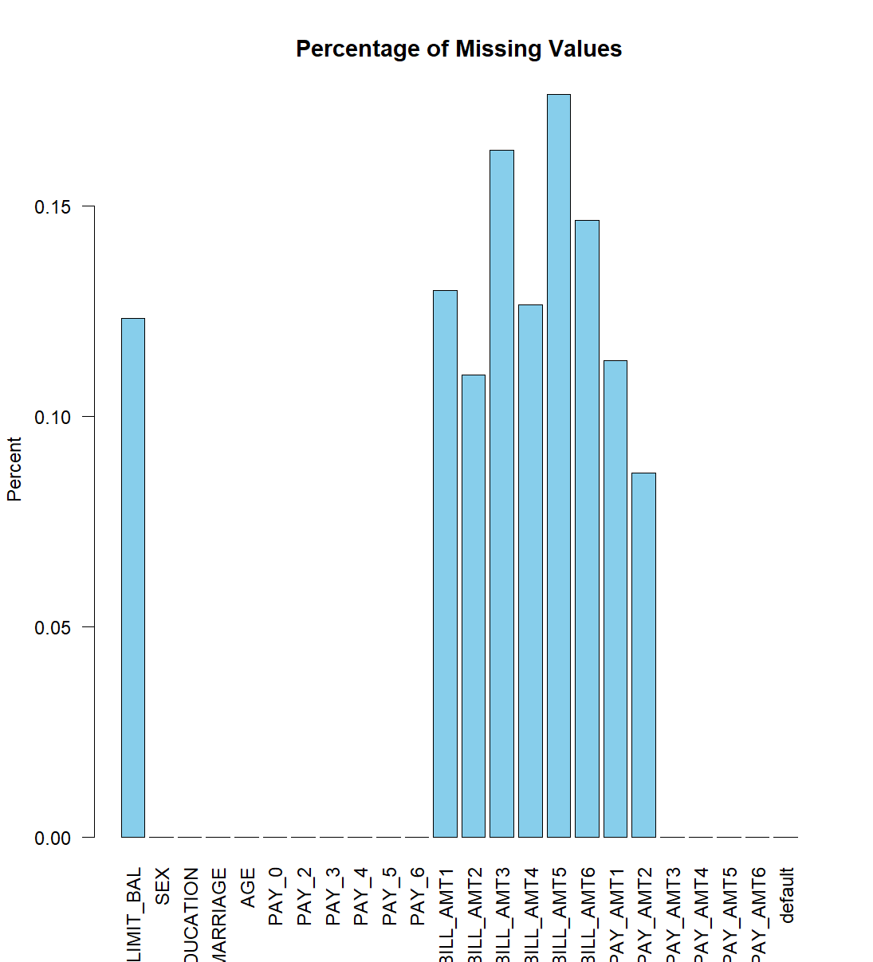

The bar plot demonstrates how each variable contains a percentage of missing values. The bar plot indicated that MICE techniques were necessary for handling missing values.

Figure 4: Comparisons of Variables Before and After Winsorization
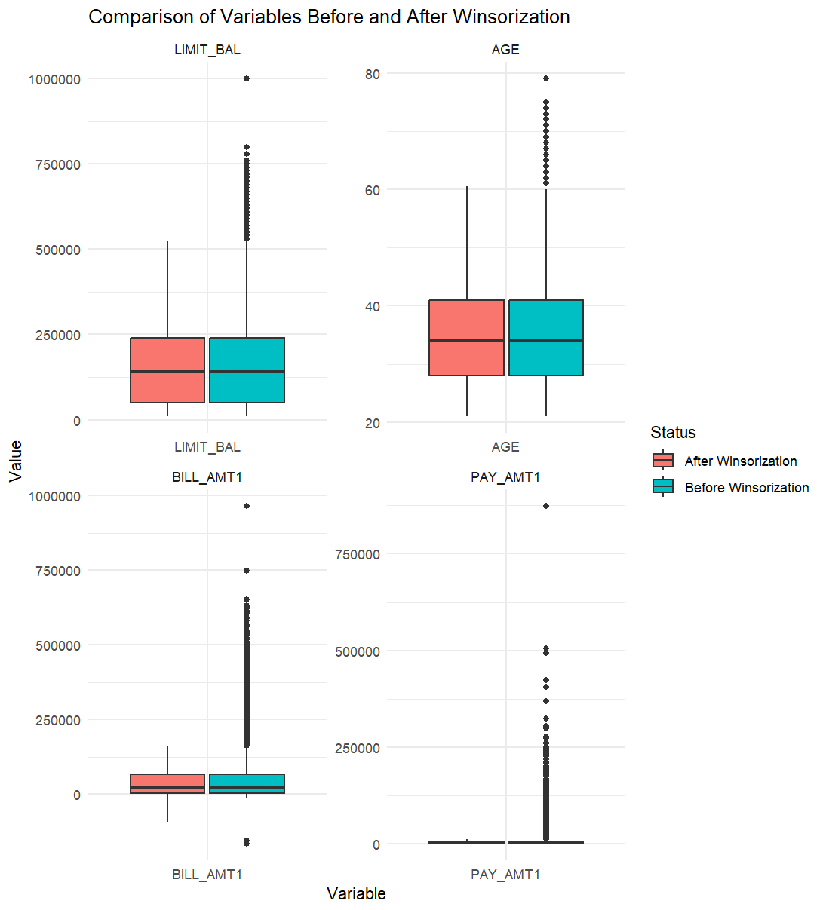

A set of boxplots shows how selected numeric variables achieved better distribution and decreased skew by removing outliers.

Section 2: Modelling Phase

Logistic Regression

- Logistic Regression functions as a supervised learning algorithm to perform binary classification operations. The algorithm determines input class probabilities through a logistic function.

Step By Step Implementation in R

Data Partitioning
- The database split into training (80%) and testing (20%) subsets through the createDataPartition () function from the caret package. The splitting process protected the original class distribution of both subsets to support unbiased training and evaluation of the model.
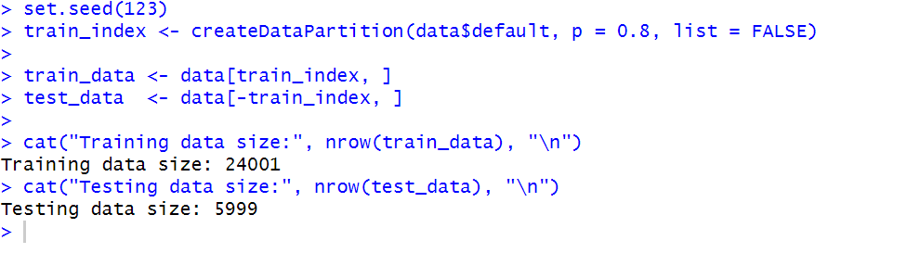

Model Training
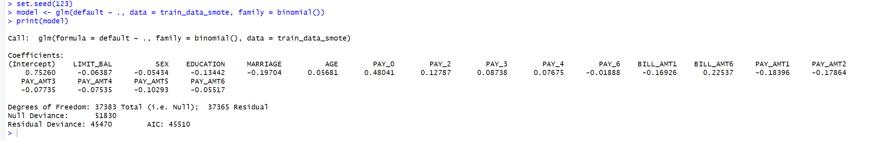
- The logistic regression model received training with the basic training dataset that needed no sampling methods or parameter optimization. The model was built using the glm() function with the binomial family, which is appropriate for binary classification problems such as predicting credit default. All available predictors were used to model the default variable. A random seed was set for reproducibility.

Prediction and Testing
- The model was used to predict the chance of default for each person in the test data. Since logistic regression gives probabilities, the model showed how likely each person was to default.
- The roc () function was then used to create a curve that helps check how well the model can tell the difference between those who will default and those who won’t.
- The best cutoff value for "Yes" or "No" predictions was determined through Youden's J method. The chosen value optimized the detection of defaults while minimizing false alarm occurrences.
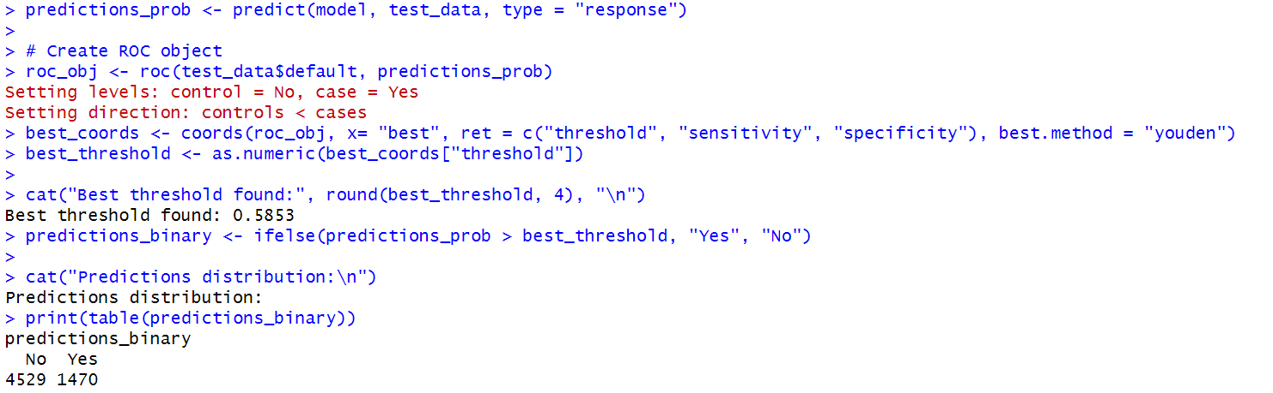
- The model classified people with forecasted probabilities above the cutoff value as "Yes" (will default) while others were classified as "No". The predicted results were evaluated against actual answers to determine the accuracy of prediction outcomes.

Evaluation
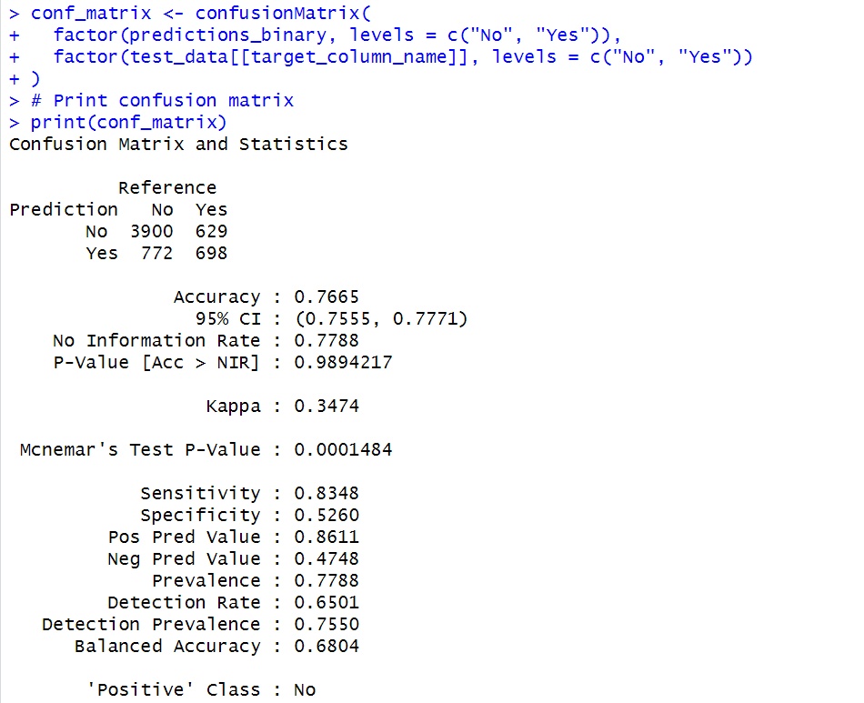
- To check how well the model worked, a confusion matrix was used. It shows how many people were correctly or incorrectly predicted to default or not default on their credit card. The code made sure that the labels "Yes" and "No" matched exactly between the predictions and the actual test data. After that, the confusion matrix was printed to display how accurate the predictions were.

Plot
- The model demonstrates its ability to separate default clients from non-default clients because the curve elevates above the diagonal.
- The Area Under the Curve value stands at 0.7248 indicating that the model correctly identifies default cases against non-default cases with a 72.48% accuracy rate.
- This model demonstrates acceptable performance according to AUC standards because its value ranges from 0.7 to 0.8 although additional improvements would enhance its effectiveness.
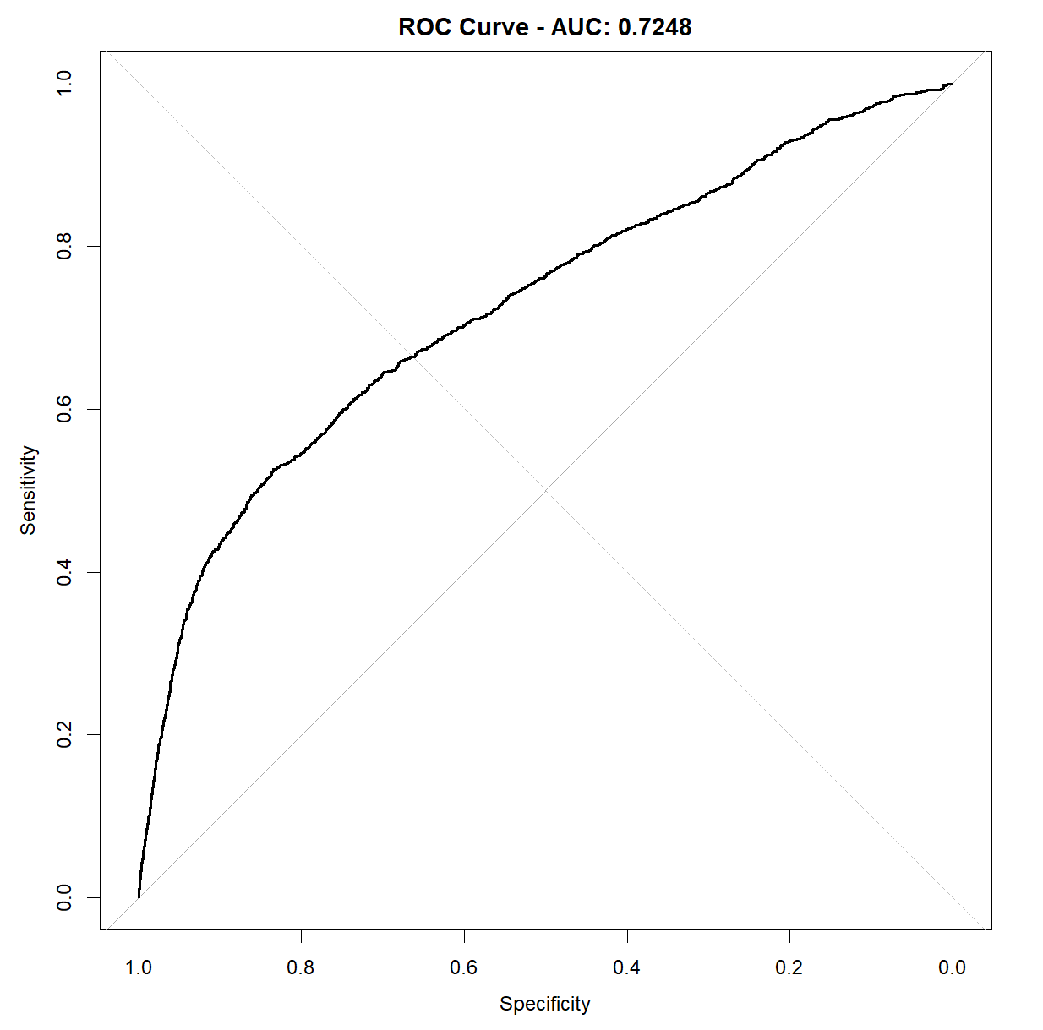

Model Improvement

Description of What Was Changed
- The model became stronger due to the following improvements:
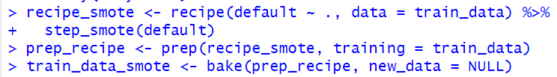
- SMOTE was employed to balance training data because of class imbalance.

- The model applied glmnet for regularized logistic regression to reach better generalization and prevent overfitting.
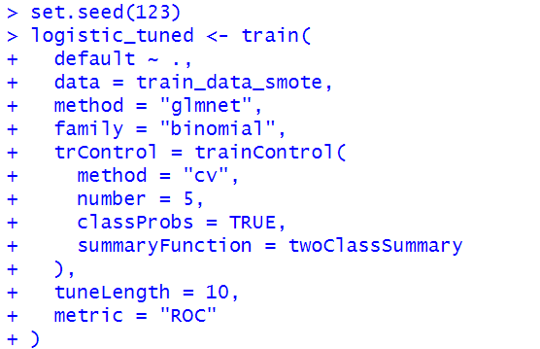
- The model received its hyperparameters through 5-fold cross-validation which selected AUC as the optimization metric.

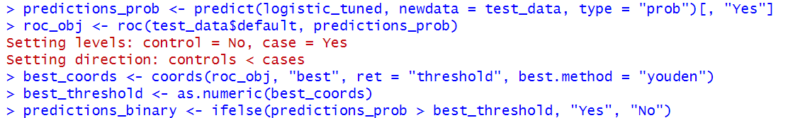
- The selection of the best classification threshold occurs through Youden’s J statistic to achieve balanced classification.

Why Were These Changes Made?
- The initial model encountered difficulty detecting default events since Yes cases appeared infrequently in the dataset. The model learned from default cases through the application of SMOTE which generated additional default examples.
- Logistic regression received an improved version to prevent overfitting by reducing the occurrence of mistakes from learning excessive details.
- The model selected an optimal threshold different from 0.5 to determine whether a case should be classified as “Yes” or “No” for better prediction accuracy.

New Results After Improvement
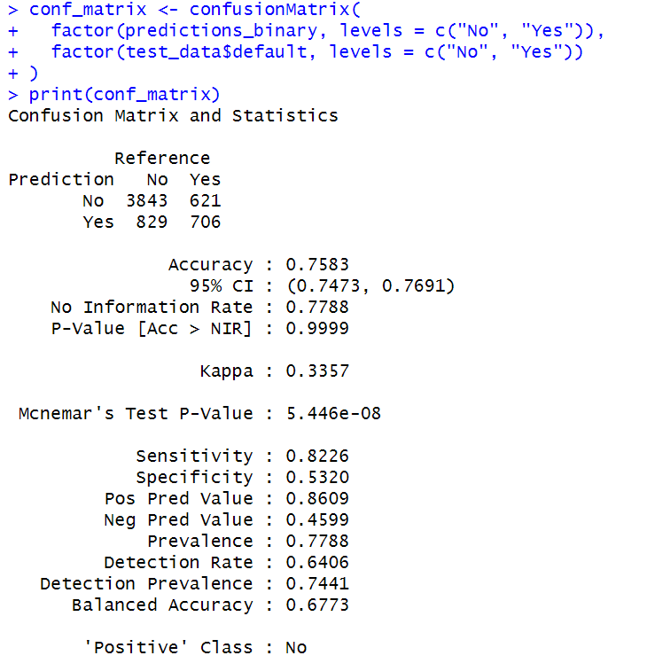

- The refined logistic regression algorithm achieved higher precision and recall rates that are crucial for performing credit default assessment. The model's overall accuracy and specificity decreased somewhat as expected from SMOTE application but achieved significant improvement in detecting actual defaulters which represents the main objective in this context. The implemented changes proved their worth because of their performance benefits.

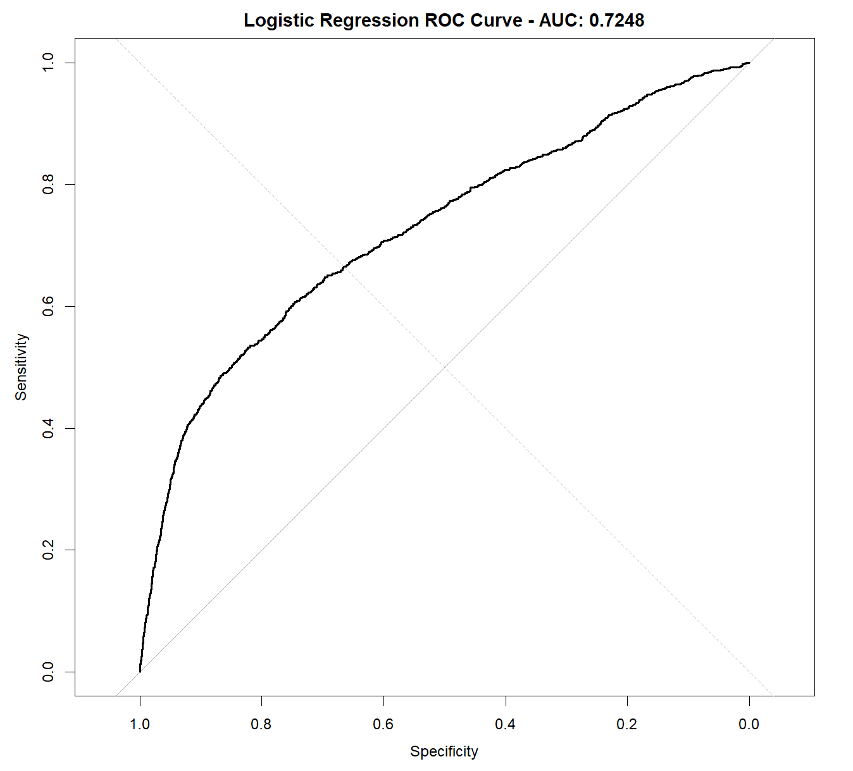
Plot

- The presented ROC curve demonstrates how well the model differentiates defaulters from non-defaulters. A reasonable ranking capability emerges from the Area Under the Curve (AUC) value of 0.7248 which shows the model places positive cases above negative cases. Performance assessment through this curve indicates better results when the plot points towards the top-left corner and this model performs better than the initial model.

KNN

- K-Nearest Neighbors (KNN) functions as a distance-based algorithm. A new data point receives its classification from the majority voting of neighboring points that surround it. The K value specifies the number of neighbors that the model will examine to determine the majority class where K=5 indicates the model uses five nearest points.

Step By Step Implementation in R

Data Partitioning
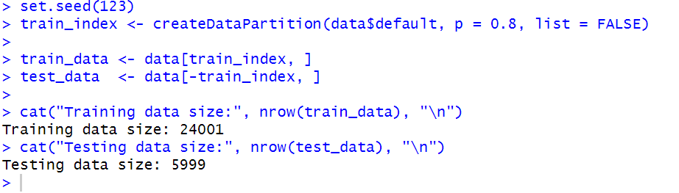
- The createDataPartition () function from caret package split the database into 80% training data and 20% testing data. The splitting method maintained the natural ratio of classes in both subsets while protecting unbiased evaluation and training for the model.

Pre-Processing (Normalization for KNN)
- The features such as age and salary and bill amounts needed normalization before training the KNN model. The processing was executed according to a specified R-based recipe.

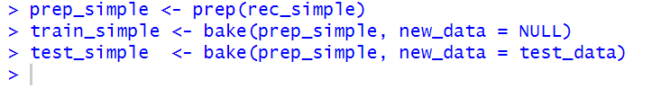
- Normalization of features guarantees equal measurement scales for the entire set of parameters. The model receives input from two columns with measurements 30,000 (salary) and 1–12 (month) which can create bias through number size variations. By normalizing the values all features acquire comparable ranges between -1 to 1. KNN substantially benefits from normalization since it determines the closeness relations between data points.

- The training data went through the recipe processing before this procedure applied (baked) the same measurements to both training and testing datasets.

Model Training
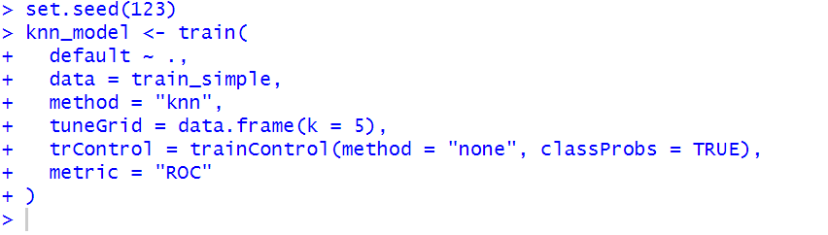
- After data normalization the KNN model proceeded with training.

- The model bases its predictions on examining 5 nearest neighbours (k = 5). The model predicts "Yes" when most of the 5 nearest neighbours have defaulted. The model predicts "No" when most of the 5 nearest neighbours did not default.
- The model operates without cross-validation during training because it remains in its basic form. The model provided prediction probabilities instead of binary responses so we could generate ROC curves to select the optimal threshold later.

Prediction and Testing
- The KNN model produced probability values to estimate default chances for each person in the test set.
- The generated probabilities led to an ROC curve for showing the classification abilities between defaulters and non-defaulters.
- Youden’s method selected the optimal threshold from the ROC curve by finding the point that maximises both sensitivity and specificity.
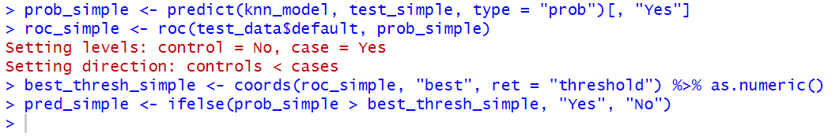
- The model transformed probabilities into final class predictions through a threshold process where probabilities above the selected value resulted in "Yes" (default) predictions and all other cases became "No" (no default). The method enhances prediction accuracy by adjusting it to match the distinct characteristics found in the dataset.

Evaluation
- The KNN model's default prediction accuracy appears in the confusion matrix. The KNN model accurately determined 3644 non-defaulters and 721 defaulters out of all test cases. The model demonstrated 72.76% accuracy which indicated its correct predictions exceeded incorrect ones.
- The model demonstrated high skill in detecting non-defaulters with an 78% sensitivity rate, yet it displayed poor ability to identify defaulters with a 54.33% specificity rate. Most people who received the prediction of non-default status actually went on to avoid defaulting according to the precision rate (85.74%).
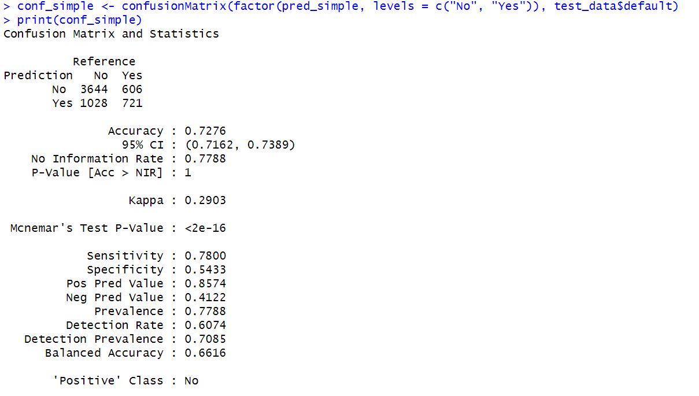
- The 66.16% balanced accuracy provides a more unbiased evaluation through an average calculation of sensitivity and specificity rates.

Plot
- The ROC curve evaluates KNN model performance in distinguishing defaulter cases (Yes) from non-defaulter cases (No). The ROC curve displays sensitivity values against 1-specificity values at different threshold points.
- The model demonstrates moderate discriminating capabilities between classes with an AUC (Area Under the Curve) score of 0.7044. A model achieves perfect accuracy when its AUC reaches 1.0 while a value near 0.5 indicates the model performs at random guessing level.
- The KNN model shows some predictive capability even though it requires further development through parameter adjustment and unbalanced class management.
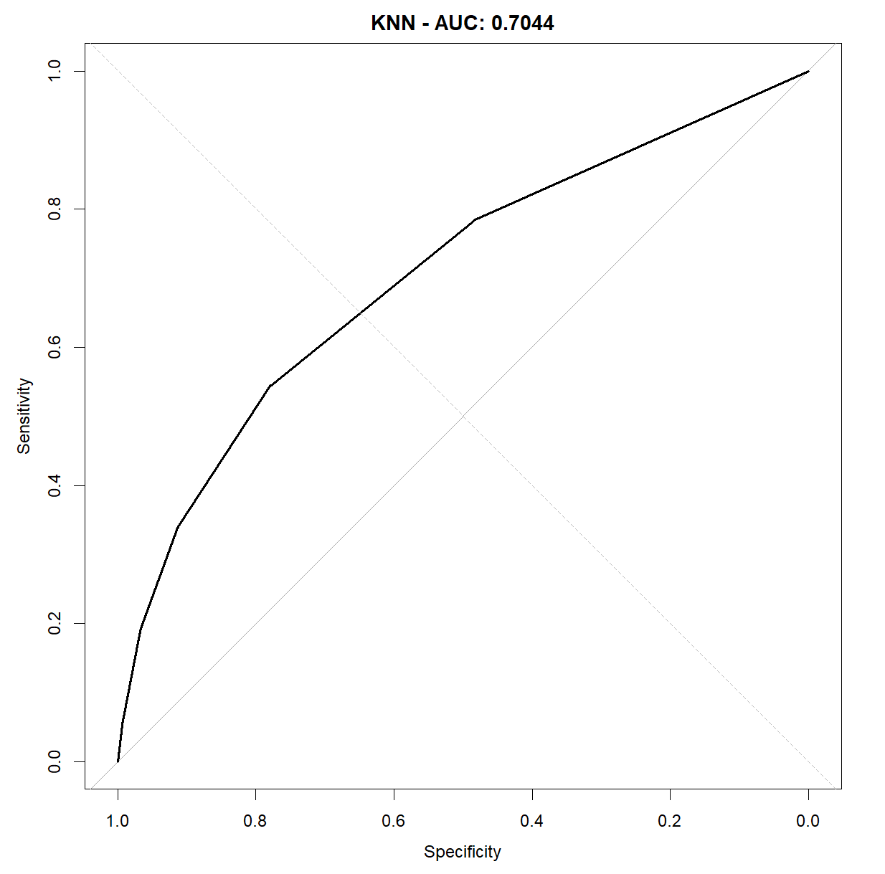

Model Improvement

Description of What Was Changed
- To improve the KNN model, two key modifications were made:
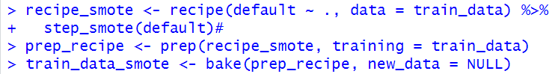
- The training data received a balancing treatment through SMOTE to resolve problems with unbalanced class distribution.

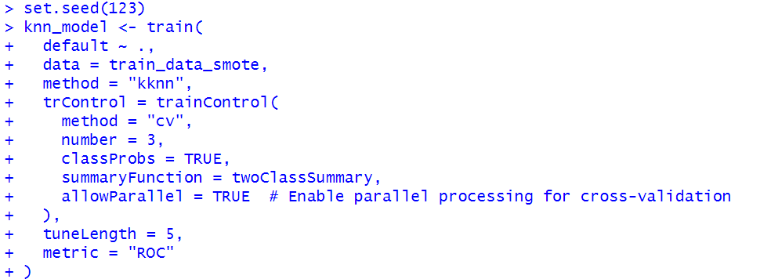
- Second, hyperparameter tuning was introduced using the train() function with 3-fold cross-validation to find the best value of k (the number of neighbours).

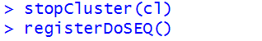
- This process was enhanced using parallel processing to optimize computation time.

Why Were These Changes Made?
- The modifications became essential because the initial model which learned from unbalanced data showed preference for the dominant class ("No" for default). The model might fail to identify minority instances ("Yes") because of this modification.
- The dataset becomes balanced through SMOTE which enables the model to detect both classes with equal fairness.
- The model went through hyperparameter tuning which determined the optimal k value because it enhanced the prediction performance and Area Under the Curve (AUC) through efficient model complexity management.

New Results After Improvement

- When we implement SMOTE and optimize the model for performance:
- The accuracy rate reached 71.55% which demonstrated a minor decrease from the basic model performance.
- The sensitivity level reached 79.09% which indicates stronger detection of non-defaulters.
- Specificity dropped to 44.99% because of this change leading to more incorrect positive predictions.
- The AUC was 62.04%, suggesting only a modest improvement in the model’s ability to distinguish between the two classes.
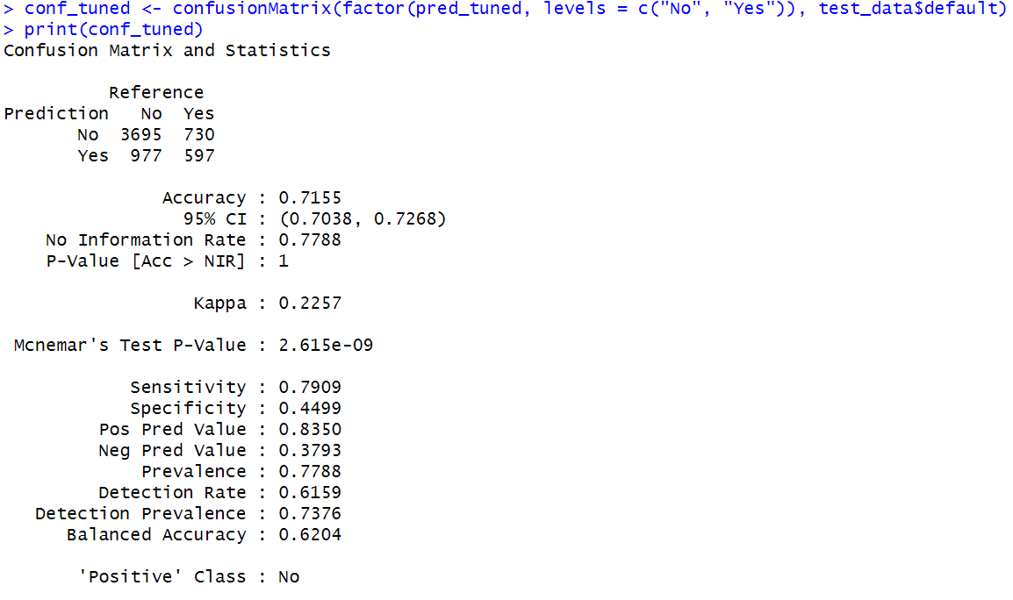
- The model became fairer by improving sensitivity without reducing specificity though accuracy and specificity levels decreased.

Plot
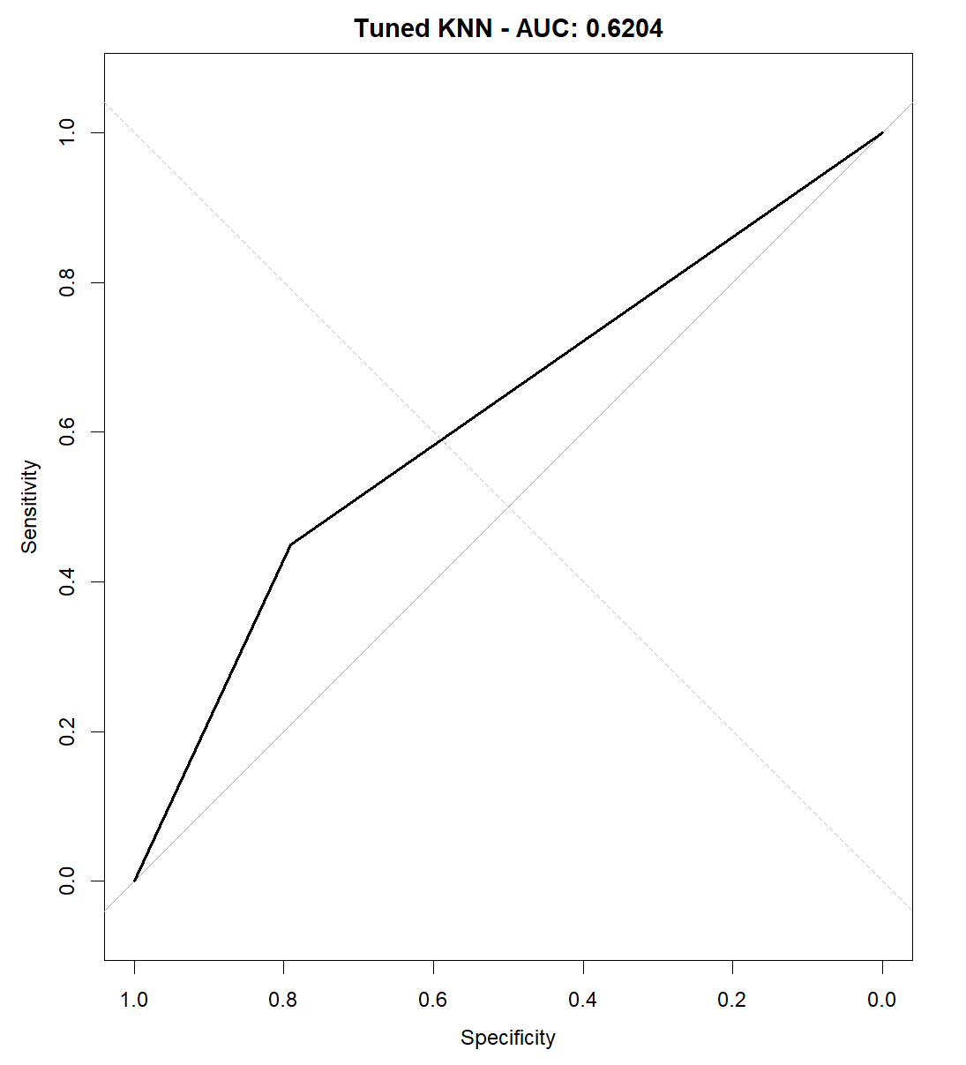

- The ROC curve shows the quality of model distinction between defaulters and non-defaulters.
- A value of 0.62 for AUC demonstrates that the model produces results slightly better than random guessing yet demonstrates weak performance.

Naïve Bayes(NB)
- Naïve Bayes functions as a basic probabilistic classification technique that applies Bayes' Theorem to features which become independent after defining the class label. The algorithm delivers good results for practical problems where the independence conditions are approximately valid.

Step By Step Implementation

Data Partitioning
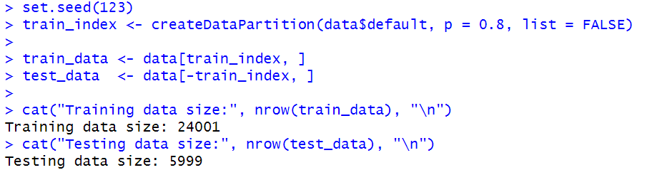
- For model training and evaluation purposes we divided the dataset into an 80% training section and a 20% testing section through caret::createDataPartition(). This approach maintained equal default and non-default proportions between the subsets.

Model Training
- The caret::train() function applied Naïve Bayes modelling to the training dataset. The results could be exactly reproduced through the implementation of a fixed random seed (set.seed(123)).
- The training set underwent five-fold cross-validation (method = "cv", number = 5) which divided it into five parts for model training on four parts followed by validation on the remaining fifth part until all parts served as validation.
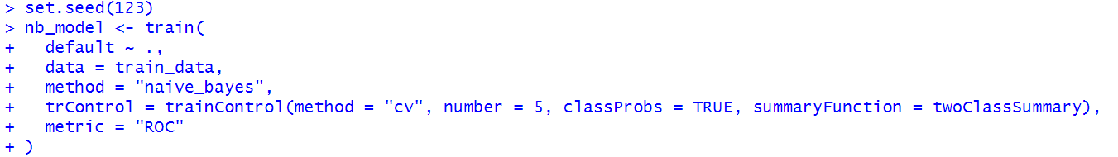
- The model generated class probability estimates (classProbs = TRUE) while using ROC AUC (summaryFunction = twoClassSummary, metric = "ROC") as its primary performance metric.

Prediction and Testing
- Predicted classes and probabilities were generated for the test set. The predict() function provided class labels yet we obtained class probabilities for the "Yes" category to enable AUC and ROC analysis.

Evaluation
- The Naive Bayes model was assessed using the test data through accuracy, sensitivity, specificity, and AUC metrics:
- Accuracy: 80.08% – the model correctly predicted default status for 8 out of 10 clients.
- Sensitivity: 95.76% – it was highly effective at identifying clients who would not default.
- Specificity: The model's ability to identify actual defaulters was poor because its specificity rate reached only 24.87%. This resulted in numerous incorrect positive predictions.
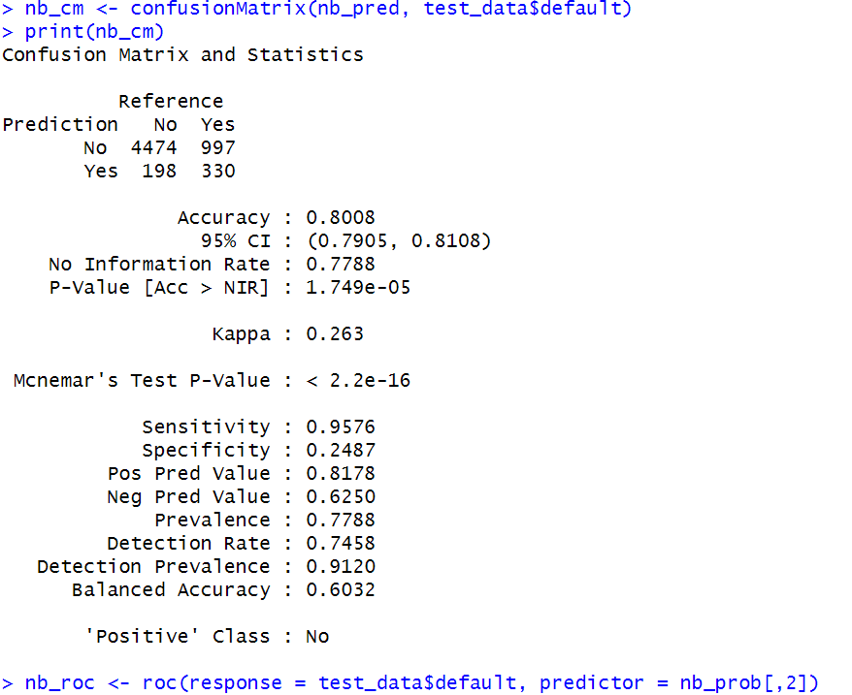
- AUC: 0.7471 – the model has a fair ability to distinguish between defaulters and non-defaulters overall.

- The model demonstrates high accuracy but shows an unbalanced distribution between sensitivity and specificity because it tends to predict non-defaulters potentially due to dataset class imbalances.

Plot

- The ROC curve demonstrates how effectively the model distinguishes between those who default payments and those who do not.
- The model demonstrates moderate performance through its AUC value of 0.7471 which exceeds random guessing accuracy.
- The ROC curve shows high sensitivity combined with lower specificity because it points toward the top-left corner.
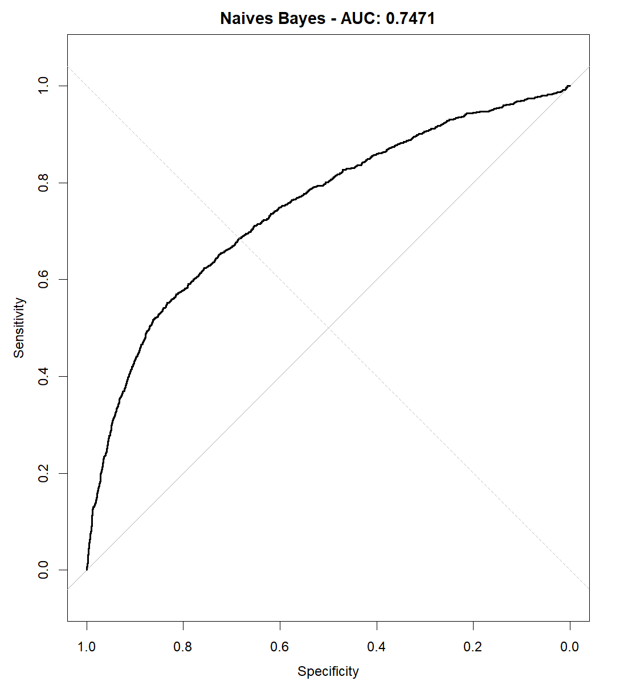

Model Improvement

Description of What Was Changed?
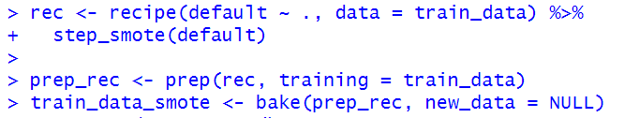
- To enhance the Naive Bayes model, the training dataset was first balanced using SMOTE through a recipe pipeline. This step addressed the issue of class imbalance by generating synthetic samples of the minority class.

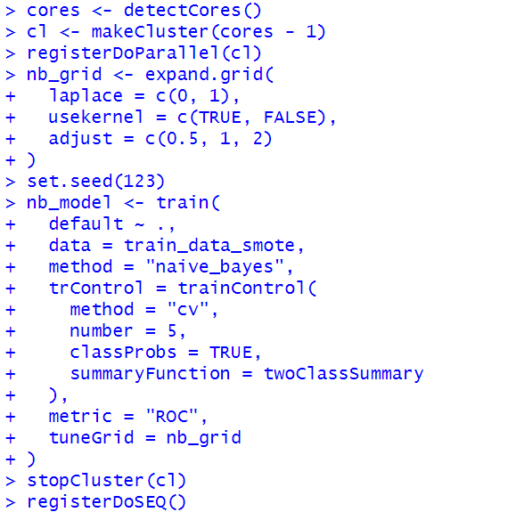
- A grid search with 5-fold cross-validation was applied for hyperparameter tuning of three variables: Laplace, use kernel and adjust.

- The process was executed in parallel to optimize computation time.

Why Were These Changes Made?
- The model demonstrated poor performance on the minority class because the initial dataset was unbalanced.
- The implementation of SMOTE helped improve the model to both classes while parameter tuning optimized performance specifically for default detection.

Model Selection Process
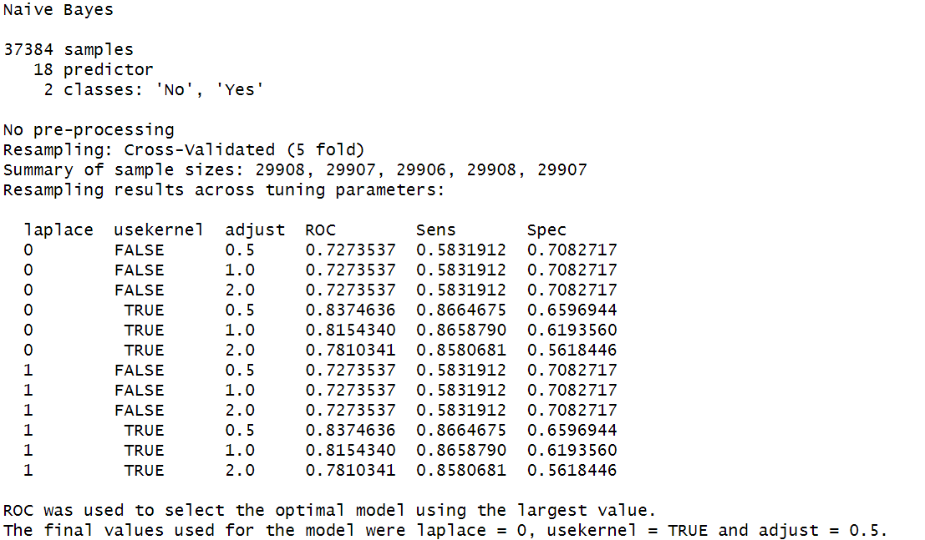
- The model with laplace set to zero and usekernel enabled and adjust set to 0.5 produced the best ROC score of 0.8375 according to cross-validation.

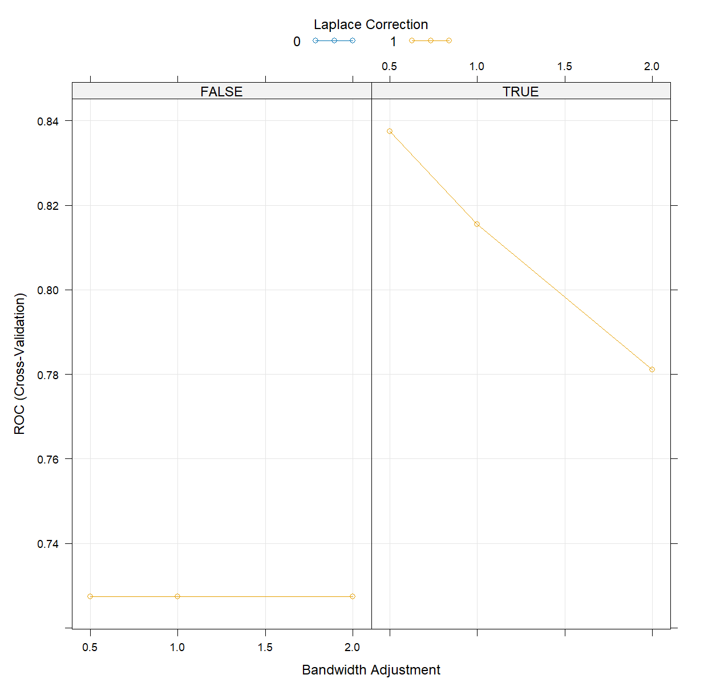
- The selected configuration delivered both high sensitivity at 0.8665 and high specificity at 0.6597.
- The graph clearly presented the laplace = 0, usekernel = TRUE, adjust = 0.5 configuration as the optimal point for classification during cross-validation.

Result After Improvement
- The final model received testing on the original test dataset with its imbalanced distribution to determine its ability to generalise.
- The final model demonstrated 77.46% accuracy together with 85.23% sensitivity and 50.11% specificity.
- The AUC value of 0.741 demonstrated better overall discrimination than the baseline version. The Kappa statistic value of 0.351 indicates that predictions match actual outcomes at a fair level.
- The model maintained its sensitivity strength but achieved only moderate improvements in specificity since correctly identifying minority class instances remained difficult.
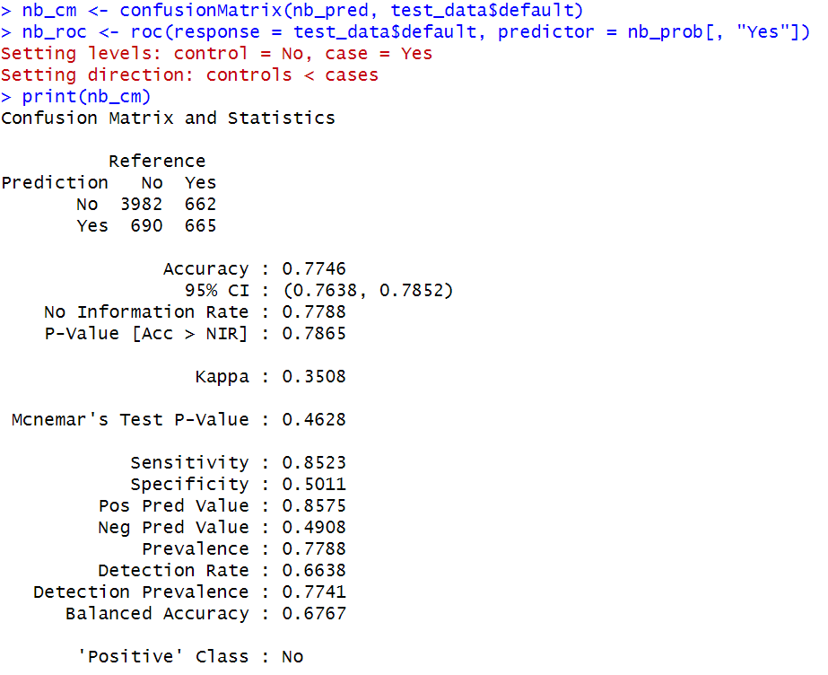
- The implementation of SMOTE and parameter tuning led to a 67.67% balanced accuracy measure.

- The enhanced Naive Bayes classifier achieved superior classification balance together with an important rise in AUC demonstrating SMOTE and parameter tuning effectiveness in managing imbalanced classification problems.

Plot
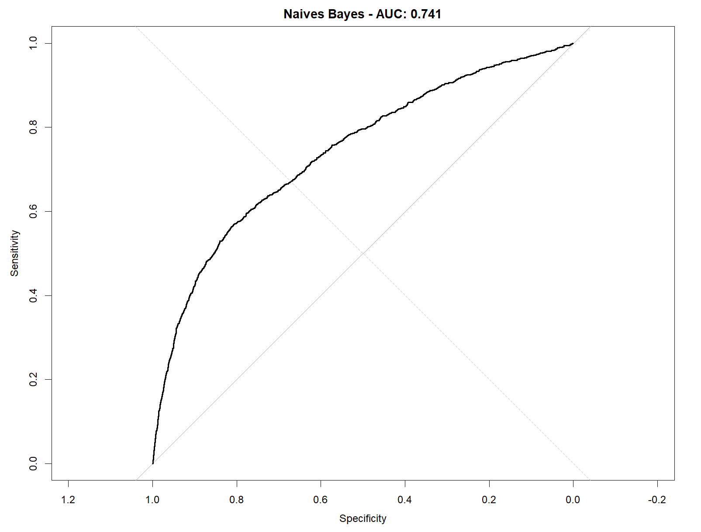

- The AUC value of 0.741 from the test data ROC curve demonstrated better model discrimination performance after tuning.

Decision Tree (DT)
- Random Forest uses ensemble learning techniques that build many decision trees to prevent the problem of overfitting (Breiman, 2001).

Step by Step Implementation in R

Data Partitioning
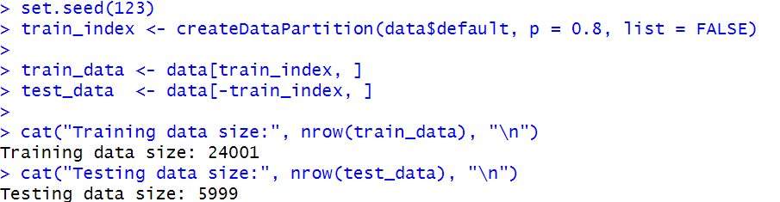
- The target variable default received factor-level conversion to "No" and "Yes" while the training and testing sets followed an 80-20 partition method. A seed was established for reproducibility purposes.

Model Training
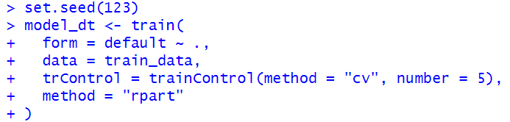
- The caret package's rpart method built a fundamental decision tree classifier. The model stability and overfitting prevention were achieved through 5-fold cross-validation.

Prediction and Testing

- The trained decision tree model processed test data by generating predictions for class probabilities.
- The ROC curve analyzed these probability values to select the optimal classification threshold.
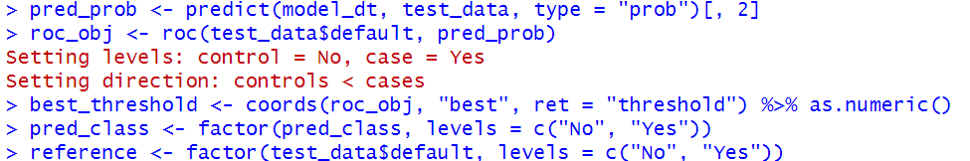
- The coords() function determined the optimal threshold value by utilizing the Youden index.

- The final class predictions resulted from comparing predicted probabilities against this threshold value.

Evaluation
- The values measure the performance of the decision tree model when classifying new data. The model achieved 82.08% success in correctly identifying test data.
- The sensitivity rate of 95.98% demonstrates that the model performs well in identifying customers who did not default.
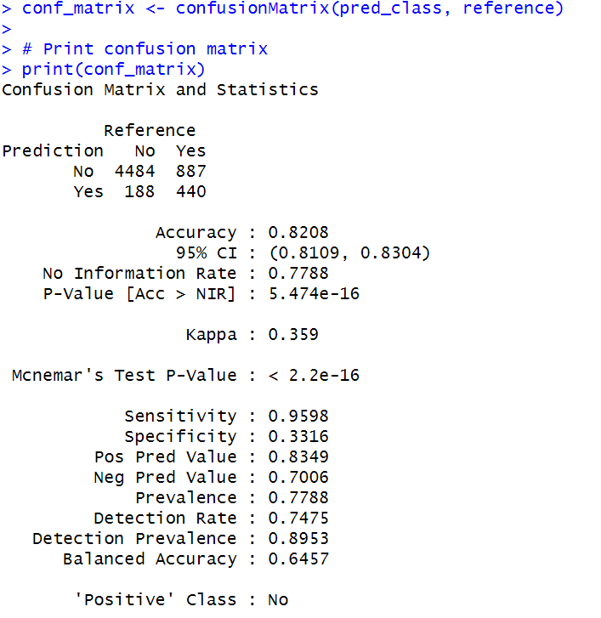
- The model demonstrates poor ability to correctly identify defaulters because its specificity reaches only 33.16%.

- While offering moderate discrimination through an AUC score of 0.6457 the model lacks experience in better separating classes.

Plots
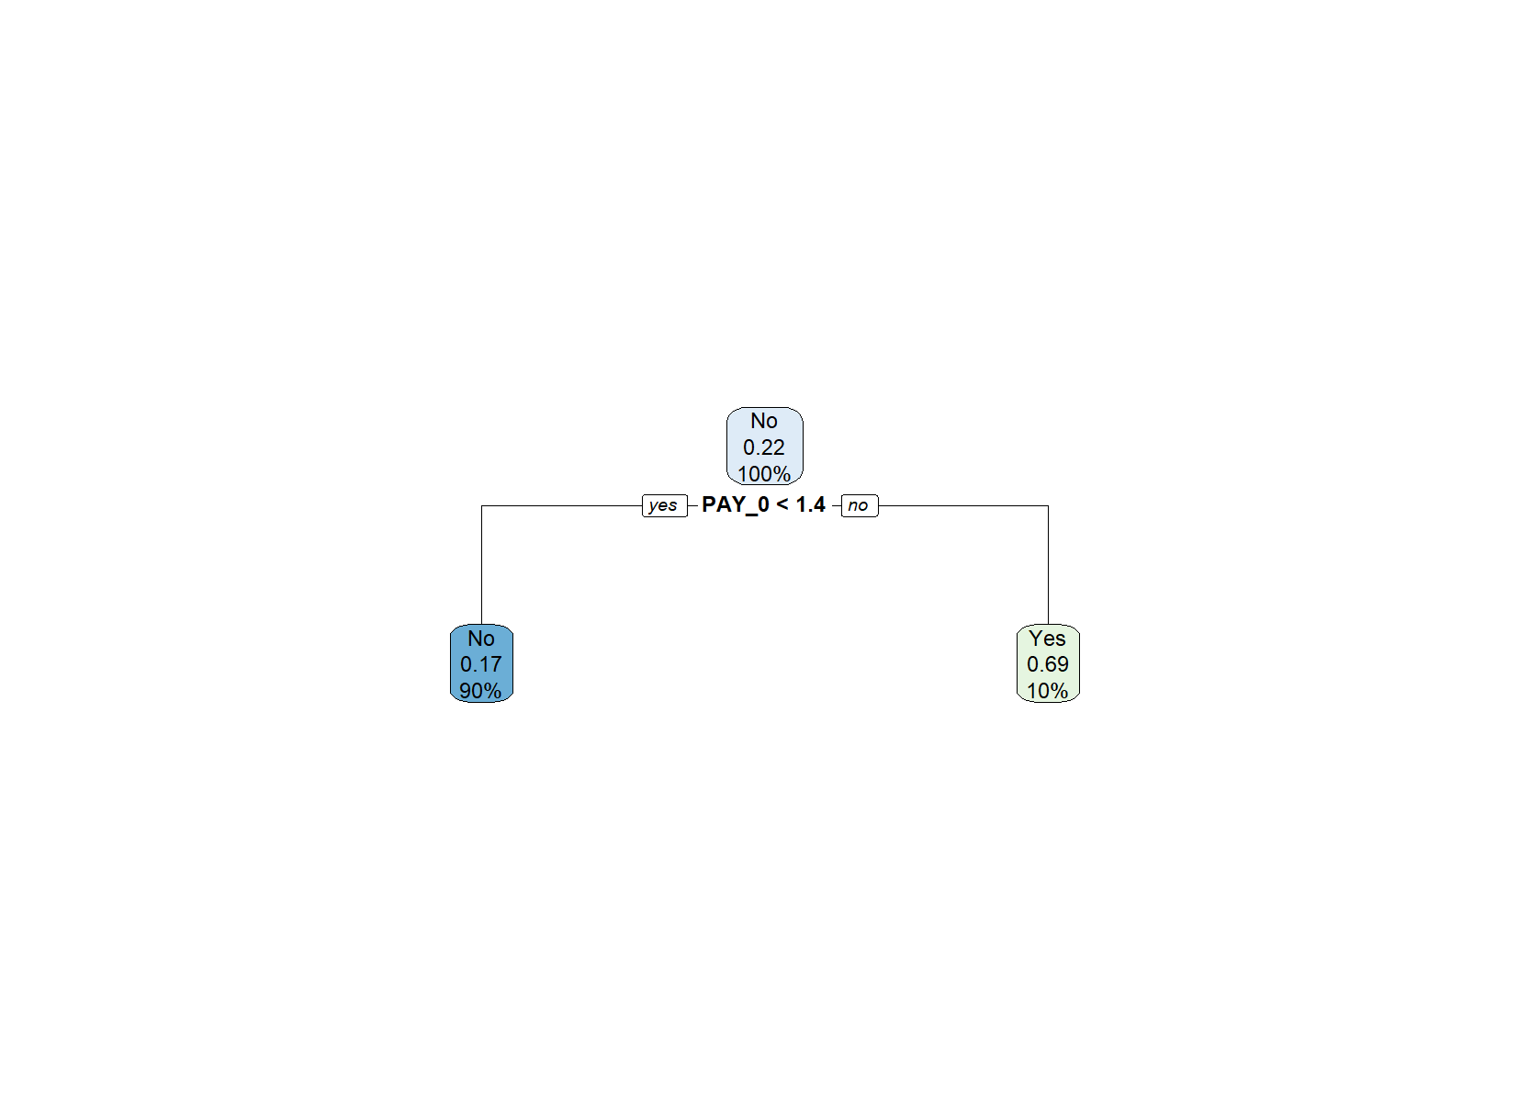
- The decision tree structure was visualized using the rpart.plot function.

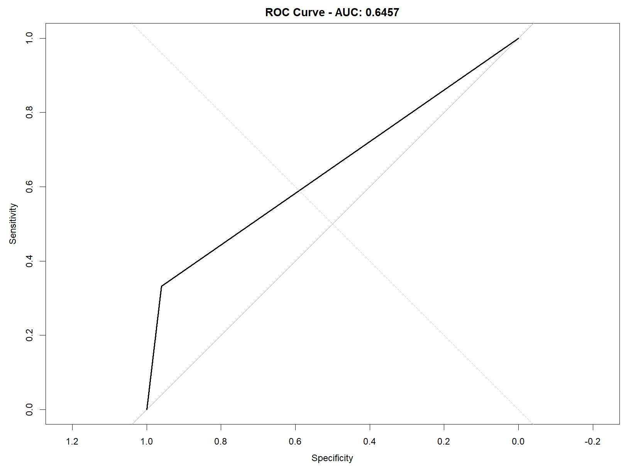
- The model demonstrated its classification capabilities through the creation of a ROC Curve.

Model Improvement

Description Of What Was Changed
- In the initial model (before tuning), we trained a basic Decision Tree (DT) classifier using the rpart method in R. The following changes were made to improve the model:
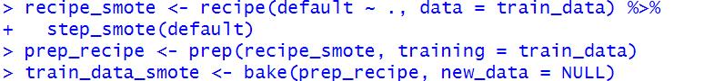
- The training dataset received SMOTE treatment to balance its classes by oversampling the minority class (default = Yes) to resolve class imbalance problems.

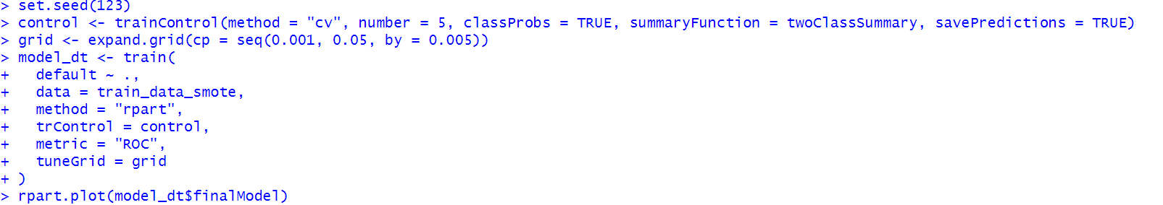
- To determine the best cp parameter value for tree complexity a hyperparameter grid search was implemented. The research analysed values between 0.001 and 0.05 with step increments of 0.005.

- The model used five-fold cross-validation to evaluate new data and avoid overfitting.
- The ROC curve with Youden index served as the standard method to optimize the classification threshold based on its sensitivity and specificity metrics.

Why Were These Changes Made?
- The original dataset showed an unbalanced distribution because "No" instances outnumbered "Yes" instances. The unbalanced data distribution creates prediction biases. The introduction of new "Yes" cases through SMOTE helped achieve data balance without allowing the model to favour the majority class.
- The cp parameter in decision trees requires hyperparameter tuning to manage their complexity level. The cp value determines tree depth which can result in overfitting the training data but also creates simpler models. The cp parameter needs adjustment to find the right balance between underfitting and overfitting.
- The performance of a model can be accurately estimated through cross-validation because it demonstrates its ability to handle new data sets.
- Using ROC performance to modify classification thresholds allows models to match predictions with selected metrics. The Youden index method allows maximum enhancement of sensitivity and specificity to improve classification precision.

New Results After Improvement
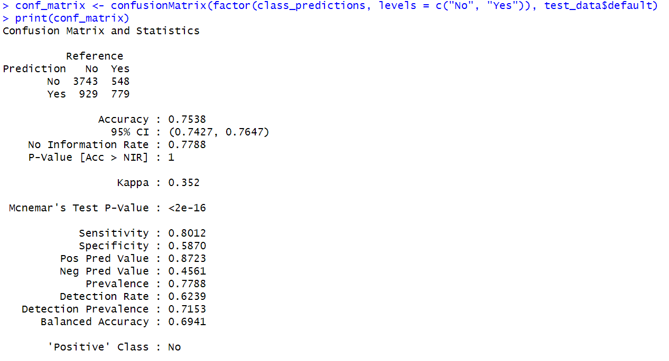
- After applying these changes, the model performance on the test set is as follows:

- The modified model achieved better defaulter detection by maintaining improved sensitivity and specificity, yet it showed a small reduction in overall accuracy.

Plots
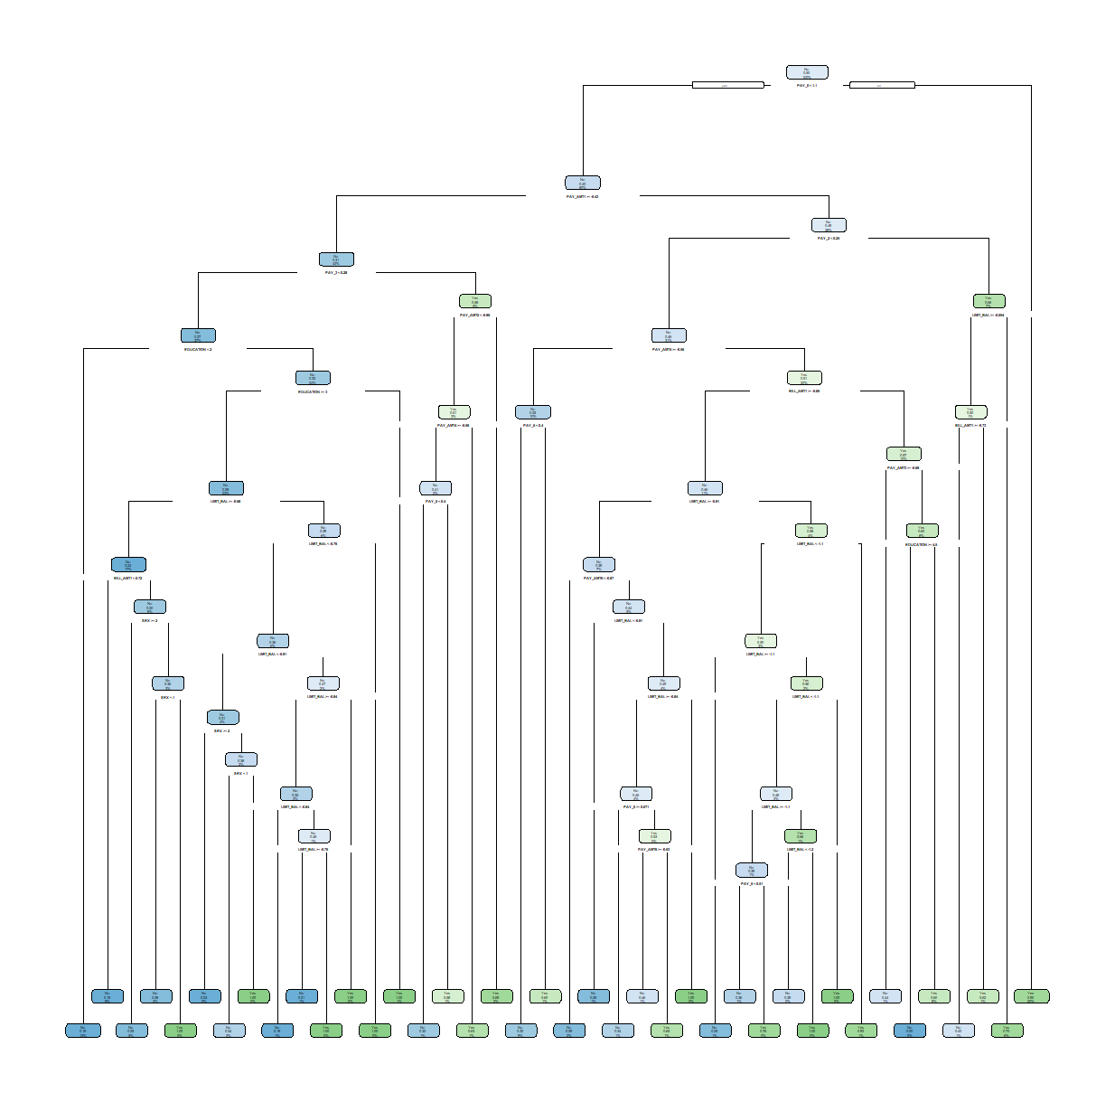
- The implementation of SMOTE and 5-fold cross-validation allowed the model complexity to increase. The decision tree improves data pattern recognition by expanding its branching structures to include multiple features.

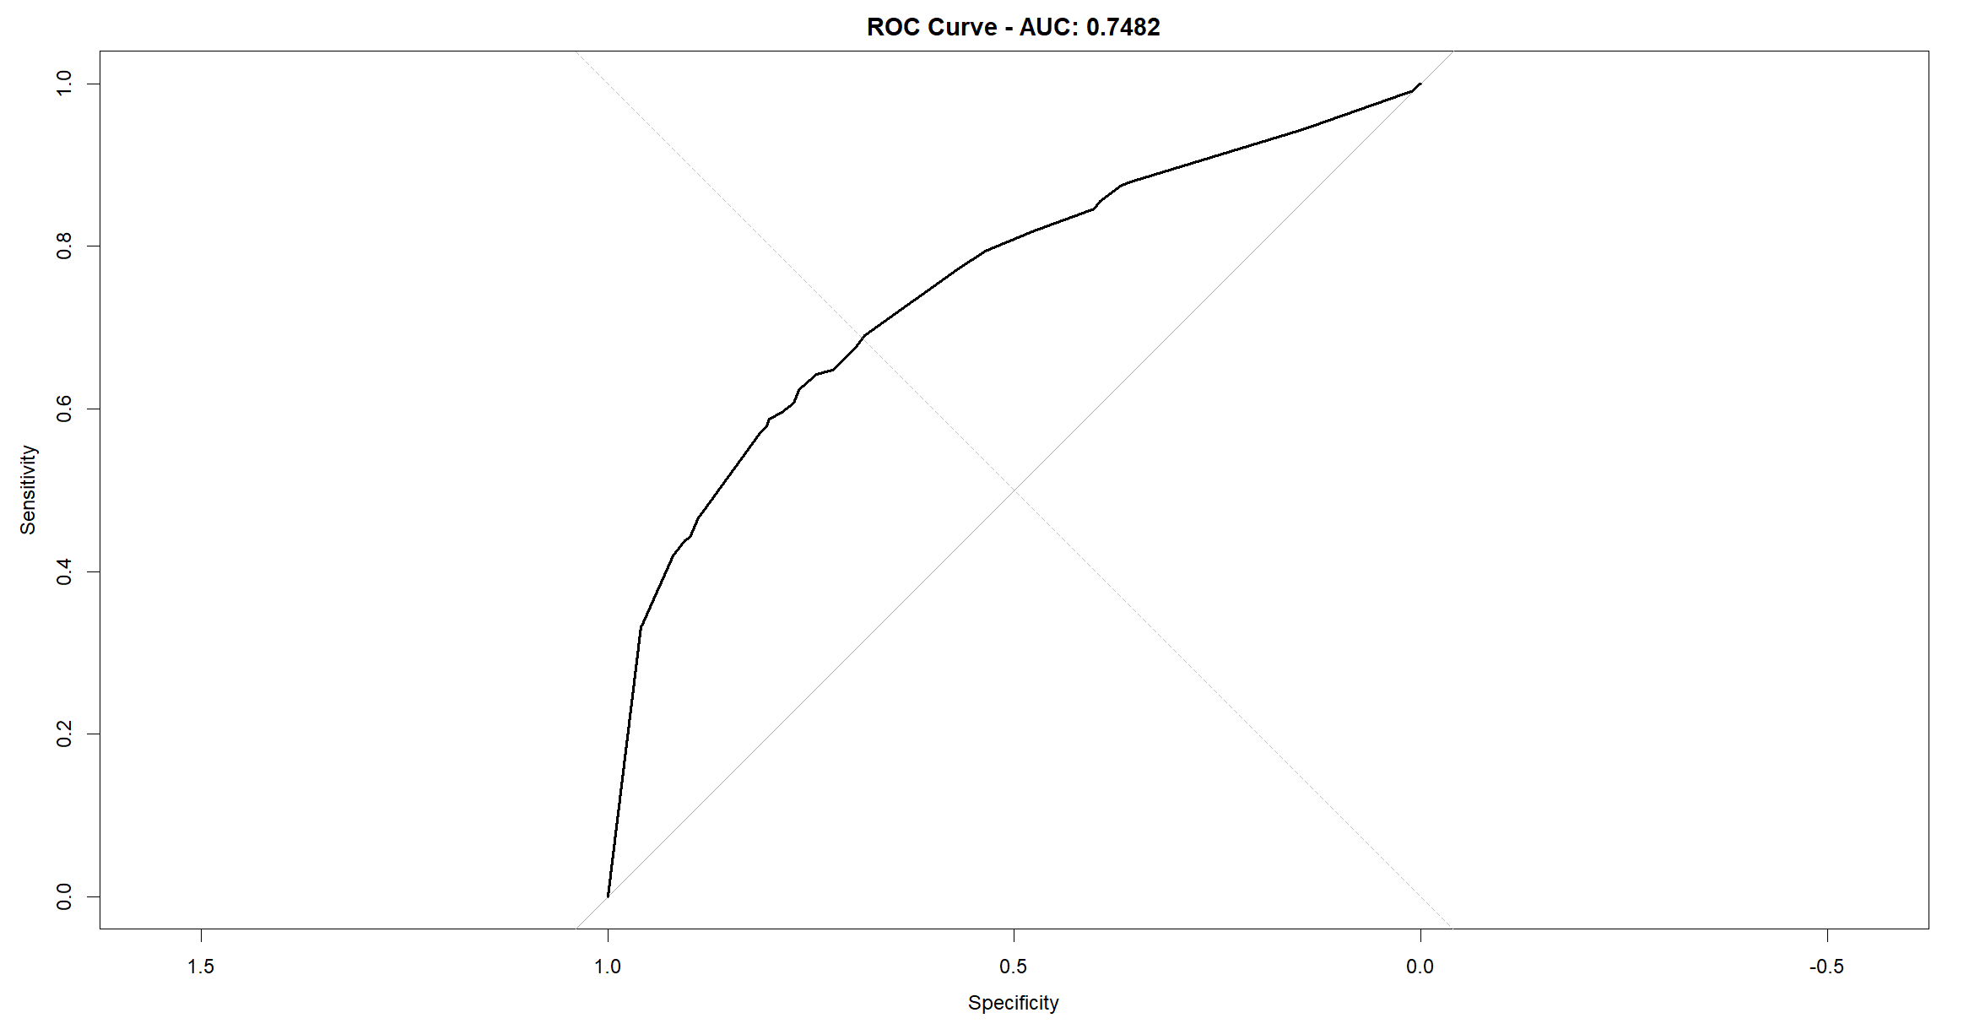
- Application of SMOTE to balance classes combined with cross-validation of the cp parameter led to an AUC improvement to 0.7482.

Random Forest (RF)
- A random forest is an ensemble of decision trees, where each tree is built from a bootstrapped version of the training data set.

Step By Step Implementation in R

Data Partitioning
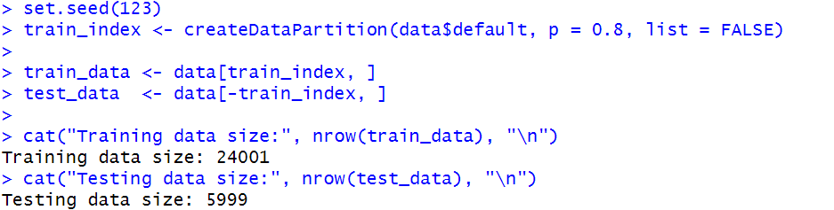
- The dataset is first partitioned into training and testing sets to ensure the model is trained on one subset and evaluated on a separate, unseen subset. In this case, 80% of the data is used for training, and the remaining 20% is reserved for testing.

Model Training
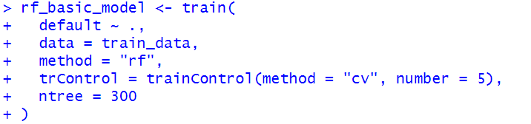
- In this step, the Random Forest model is trained on the train_data using the train() function from the caret package. The model is built with 300 trees and evaluated using 5-fold cross-validation to prevent overfitting.

Prediction and Testing
- Once the model is trained, it is used to make predictions on the test dataset. The analysis of data points helps validate the accuracy match between predicted outcomes and estimated data.

- predict() is used to make predictions on the test set (test_data).
- performance metrics emerge from (confusionMatrix()) as it applies (rf_pred) to validate (test_data$default) actual outcomes.

Evaluation
- The performance of the model is measured in terms of metrics such as, accuracy, sensitivity, specificity and AUC (Area under Curve). Also, a ROC curve is plotted to visualize the classification of the model.
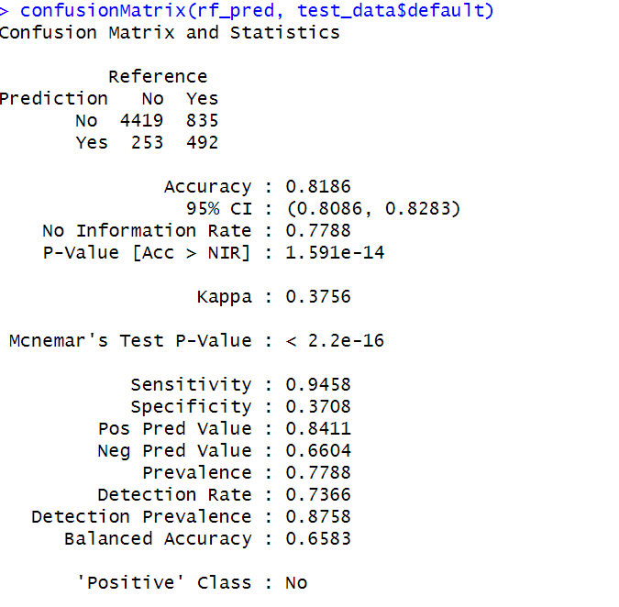

- The model achieves high accuracy in identifying non-default cases but faces difficulties identifying default cases which could result in many misclassified defaulters. The model displays an uneven data distribution that Favor’s the majority class.

Plot
- The ROC curve demonstrates successful learning by rising above the random guessing line.
- AUC 0.7597 suggests reasonably good performance, performance will continue to gain by increased techniques in data balancing plus hyperparameter fitting.
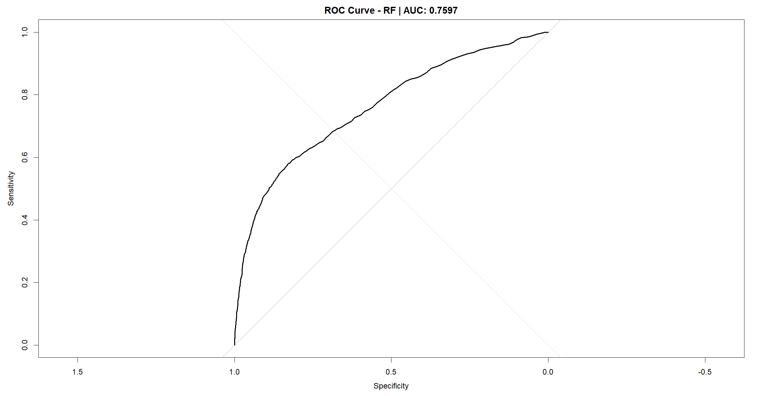

Model Improvement

Description of What Was Changed
- The initial Random Forest framework received two important updates to boost its performance level:
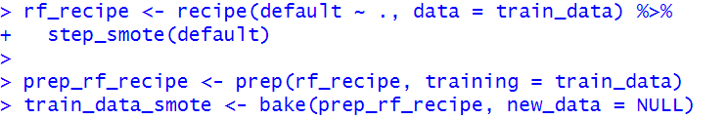
- Synthetic Minority Over-sampling Technique (SMOTE) helped resolve the class imbalance problem found in the training data.

- Hyperparameter tuning were done for mtry (number of variables randomly sampled at each split) using 5-fold cross-validation.
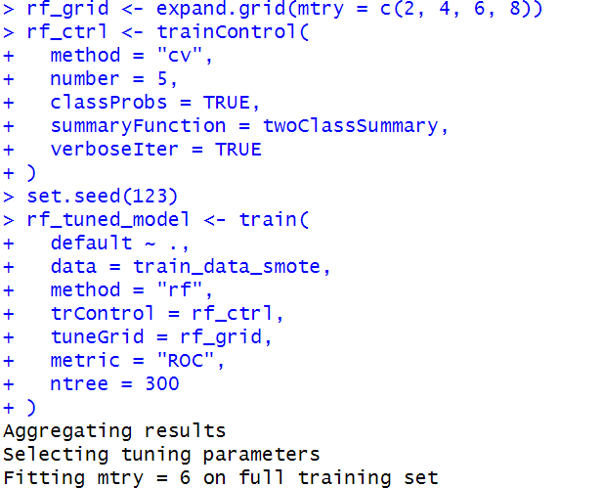

Why Were These Changes Made?
- SMOTE operates to solve class imbalance issues essential for binary classification problems that have an underpopulated class such as "Yes" for default. The lack of balance correction makes models develop biases that favour the majority class.
- The model achieves better generalization performance through mtry tuning because it selects the most suitable number of variables for split decisions.
- These methods are to enhance the sensitivity, specificity, and overall AUC score of the model.

New Results After Improvement
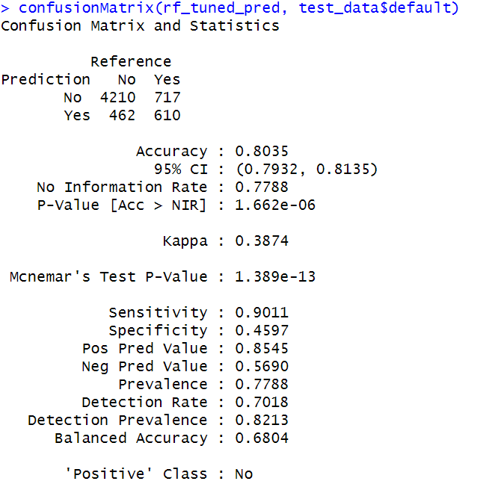
- After applying SMOTE and tuning:

- The analysis showed slightly lower overall accuracy but better identification of defaults through improved balanced accuracy and specificity and AUC.

Plot
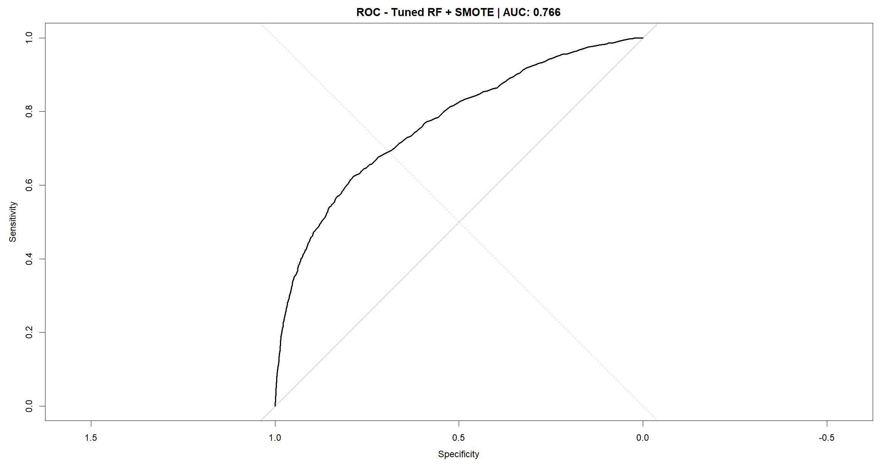
- The next ROC curve shows the enhanced model's performance:

- This curve shows that the AUC is increased to 0.766 and, therefore, the sensitivity and specificity has a better trade-off.

Multimodel (Naïve Bayes + Random Forest)
- A soft voting ensemble classifier combines the predicted probability of multiple base classifiers and picks the class label that has the highest average probability. In this case, a Random Forest and a Naive Bayes model were trained separately, and their probability predictions were averaged. This approach enjoys the benefits from both aspects of two models, enhancing robustness, and normally the performance of generalization.

Step By Step Implementation in R

Data Partitioning
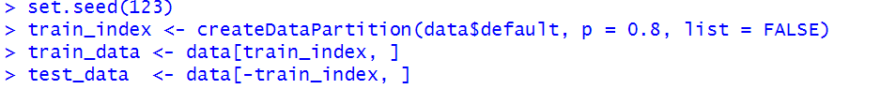
- The dataset was divided into training and test sets with 80-20 ratio using stratified sampling to maintain class balance. A conversion transformed the default variable into a factor containing "No" and "Yes" levels.

Smote Application
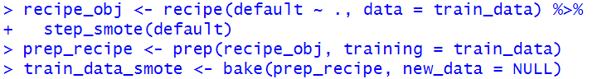
- The step_smote() function from the themis package applied SMOTE to balance classes in the training set.

Model Training
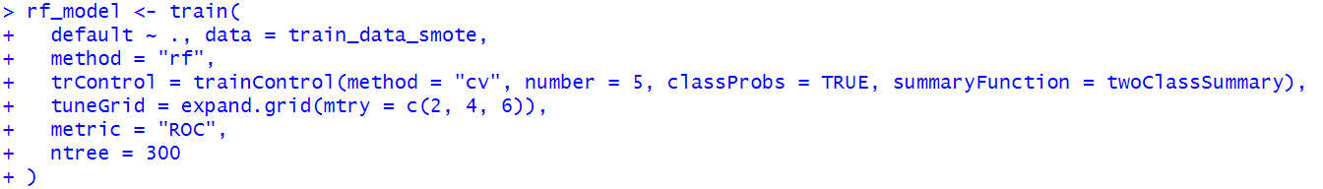
- The Random Forest model underwent 5-fold cross-validation while mtry was set to {2, 4, 6}.

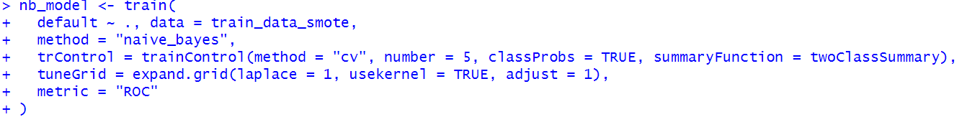
- A Naive Bayes model was trained with Laplace smoothing, kernel density estimation enabled, and an adjust value of 1.

- The models reached their optimized state by using AUC (metric = "ROC") as the main evaluation metric.

Ensemble Prediction
- After training, the class probabilities for the "Yes" class from both models were averaged:

- Final class labels were predicted using a 0.5 threshold.

Evaluation
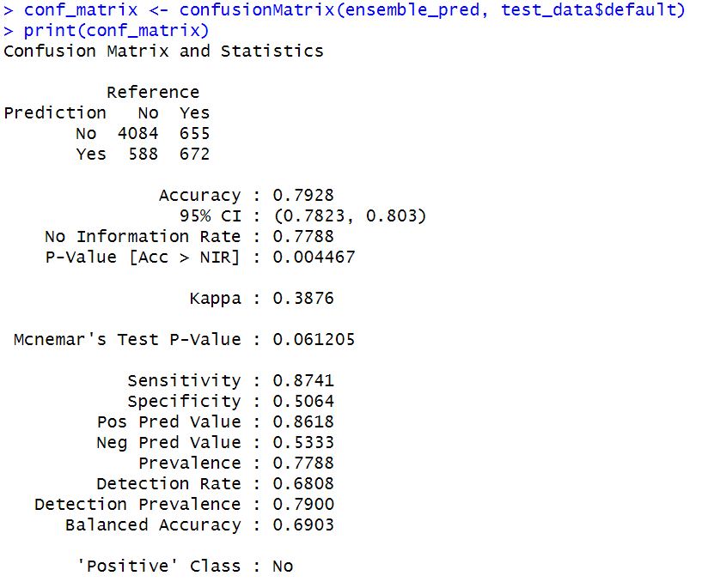
- The performance of classification appears in this confusion matrix.

Plot
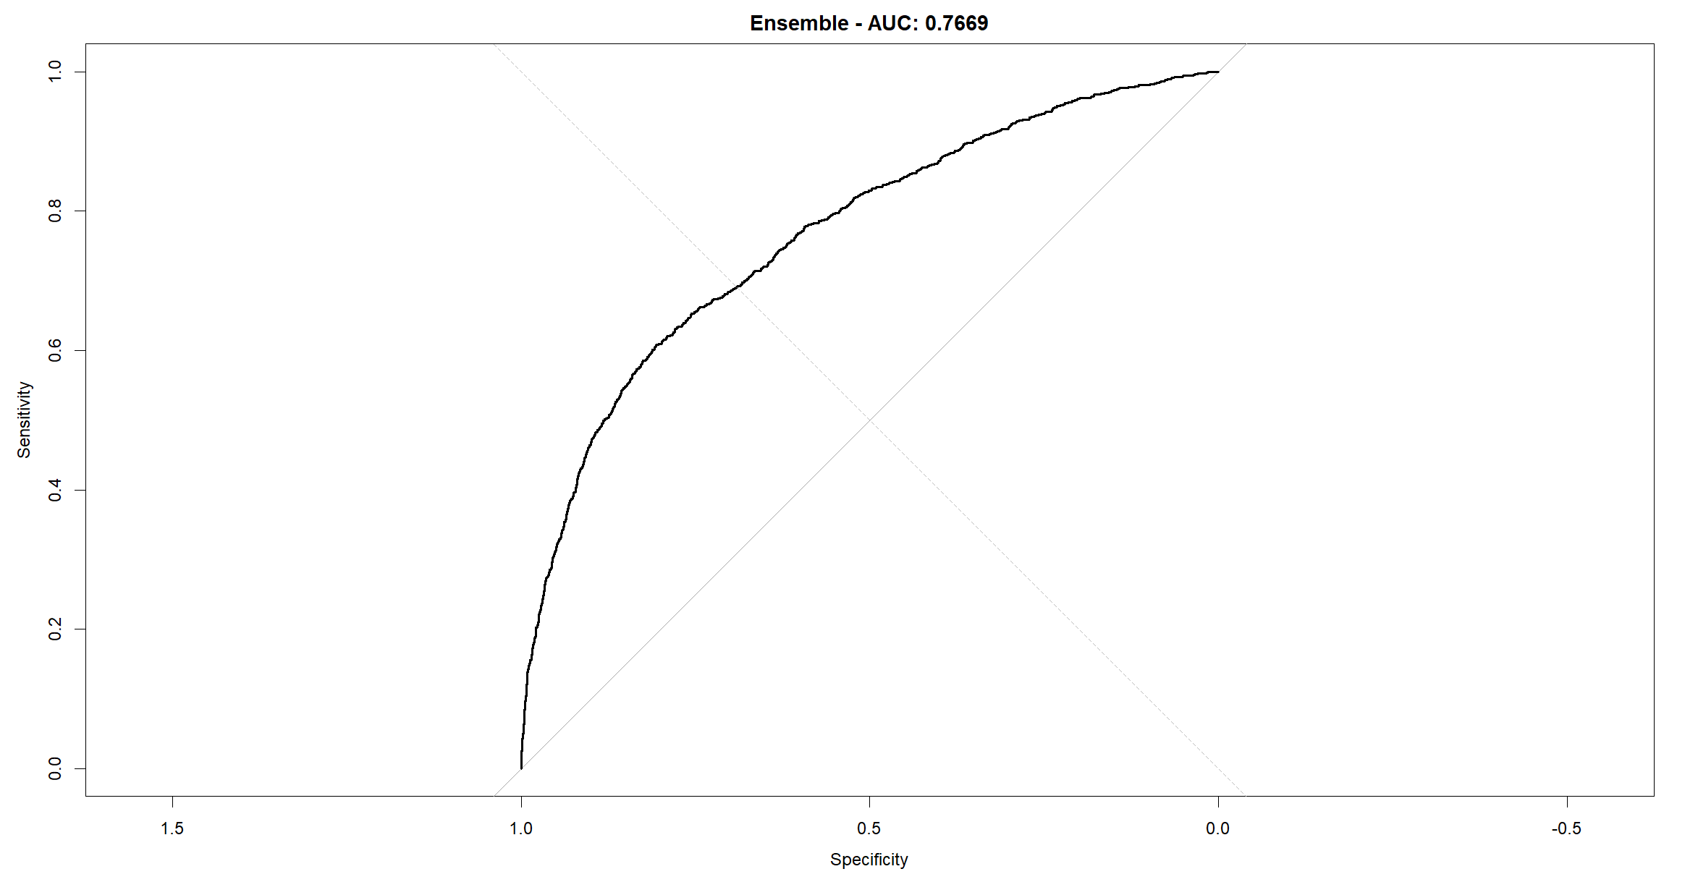
- The below figure shows the ROC curve that represents model discrimination ability.

- Ensemble AUC: 0.7669

Interpretation
- The ensemble model takes advantage of the variance-reducing aspect of Random Forest and the simplicity of Naive Bayes. The ROC and confusion matrix results show that combining these models results in more balanced and potentially more accurate predictions than any one of the individual models.

Section 3 : Model Results

Before Tuning

MODEL | ACCURACY | SENSITIVITY | SPECIFICITY | FP | FN | KAPPA | AUC
LOGISTIC REGRESSION | 0.7665 | 0.8348 | 0.5260 | 0.8611 | 0.4748 | 0.3474 | 0.7248
KNN | 0.7276 | 0.7800 | 0.5433 | 0.8574 | 0.4122 | 0.2903 | 0.7044
NAÏVE BAYES (NB) | 0.8008 | 0.9576 | 0.2487 | 0.8178 | 0.6250 | 0.263 | 0.7471
DECISION TREE (DT) | 0.8208 | 0.9598 | 0.3316 | 0.8349 | 0.7006 | 0.359 | 0.6457
RANDOM FOREST (RF) | 0.8186 | 0.9458 | 0.3708 | 0.8411 | 0.6604 | 0.3756 | 0.7597

After Tuning

MODEL | ACCURACY | SENSITIVITY | SPECIFICITY | FP | FN | KAPPA | AUC
LOGISTIC REGRESSION | 0.7583 | 0.8226 | 0.5320 | 0.8609 | 0.4599 | 0.3357 | 0.7248
KNN | 0.7155 | 0.7909 | 0.4499 | 0.8350 | 0.3793 | 0.2257 | 0.6204
NAÏVE BAYES (NB) | 0.7746 | 0.8523 | 0.5011 | 0.8575 | 0.4908 | 0.3508 | 0.741
DECISION TREE (DT) | 0.7538 | 0.8012 | 0.5870 | 0.8723 | 0.4561 | 0.352 | 0.7482
RANDOM FOREST (RF) | 0.8035 | 0.9011 | 0.4597 | 0.8545 | 0.5690 | 0.3874 | 0.766
MULTIMODEL  (RF + NB) | 0.7928 | 0.8741 | 0.5064 | 0.8618 | 0.5333 | 0.3876 | 0.7669

Section 4 : Model Performance Analysis

This section presents a comprehensive evaluation of the classification models developed for predicting credit card default, based on a comparison of performance metrics both prior to and following model tuning and resampling. The metrics evaluated include Accuracy, Sensitivity (Recall), Specificity, False Positive Rate (FP), False Negative Rate (FN), Cohen’s Kappa, and the Area Under the Receiver Operating Characteristic Curve (AUC) (Fawcett, 2006). Additionally, the performance of a multimodel ensemble (Random Forest + Naïve Bayes) is assessed to determine whether predictive accuracy can be enhanced through model aggregation (Dietterich, 2000).

Pre -Tuning Performance

Before hyperparameter tuning and class balancing techniques were applied, the Decision Tree classifier demonstrated the highest accuracy (0.8208) and sensitivity (0.9598), suggesting strong ability in identifying defaulters. The model showed limited specificity at 0.3316 which resulted in many false positive predictions. The Random Forest model also performed competitively with an accuracy of 0.8186 and an AUC of 0.7597, representing a balanced trade-off between true positive and true negative rates (Breiman, 2001).

The Naïve Bayes classifier achieved exceptionally high sensitivity (0.9576), yet its specificity (0.2487) was notably low, suggesting over-classification of defaulters. Logistic Regression and K-Nearest Neighbours (KNN) produced moderate performance across most metrics, with Logistic Regression achieving a higher AUC (0.7248) than KNN (0.7044) (Kotsiantis et al., 2007).

Post – Tuning Performance

Following hyperparameter tuning and the application of the Synthetic Minority Over-sampling Technique (SMOTE), a marked improvement was observed across all models (Chawla et al., 2002). The Random Forest model yielded improved accuracy (0.8035) and the highest AUC (0.7660) among the individual models, confirming its robustness after addressing class imbalance.

The Naïve Bayes classifier maintained strong sensitivity (0.8523) with a balanced specificity (0.5011), while its kappa score (0.3508) suggested moderate agreement. The Decision Tree model, although slightly lower in accuracy (0.7538), demonstrated a well-balanced performance with an AUC of 0.7482.

Most notably, the multimodel ensemble constructed using soft voting between Random Forest and Naïve Bayes achieved the highest AUC (0.7669) with a sensitivity of 0.8741 and specificity of 0.5064. This indicates an improved capacity to generalize across both defaulters and non-defaulters (Kuncheva, 2004).

Section 5 : Best Model Selection and Interpretation

Based on a thorough evaluation of model performance, the multimodel ensemble combining Random Forest and Naïve Bayes classifiers is identified as the most effective model. This ensemble not only achieved the highest AUC (0.7669), but also demonstrated an optimal balance between sensitivity and specificity, indicating reliable discrimination between defaulters and non-defaulters.

The ensemble model utilizes the best characteristics of its two component classifiers. Random Forest achieves reliability through two mechanisms: it prevents overfitting, and it detects intricate feature relationships (Breiman, 2001). Naïve Bayes, on the other hand, is fast to compute and performs well when detecting positive cases (Rish, 2001). By using soft voting, which averages the probability scores from both models, the ensemble achieves better accuracy and more consistent performance (Zhou, 2012).

The kappa score of the ensemble (0.3876) further supports its selection, indicating a fair level of agreement beyond chance (Cohen, 1960). This model is particularly suitable in contexts where both the minimization of false negatives and the control of false positives are essential.

Section 6 : Conclusion

This study developed and evaluated multiple classification algorithms to predict default on credit card payments using the “Default of Credit Card Clients” dataset. The model developed without tuning showed poor predictive specificity and unbalanced overall performance. The implementation of hyperparameter tuning alongside SMOTE delivered significant enhancements to model accuracy together with sensitivity and AUC. The ensemble approach which combines Random Forest and Naïve Bayes proved to be the most effective predictive model among those tested. Its performance metrics show that the model is reliable and suitable for real-world use in credit risk assessment tasks. The proposed ensemble model demonstrates strong performance for real-world applications particularly in financial institutions which need accurate defaulter identification. Future investigations should study ensemble methods such as stacking and boosting because they could enhance prediction performance.

Bibliography

- Breiman, L. (2001). Random forests. Machine Learning, 45(1), pp.5–32. [Online]
Available at: https://link.springer.com/article/10.1023/A:1010933404324
[Accessed 1st May 2025]
- Rish, I. (2001). An empirical study of the naive Bayes classifier. In IJCAI 2001 Workshop on Empirical Methods in AI, pp. 41–46. [Online]
Available at: https://faculty.cc.gatech.edu/~isbell/reading/papers/Rish.pdf
[Accessed 3rd May 2025]

- Zhou, Z.H. (2012). Ensemble methods: foundations and algorithms. CRC press. [Online]
Available at : https://www.taylorfrancis.com/books/mono/10.1201/b12207/ensemble-methods-zhi-hua-zhou
[Accessed 29th April 2025]

- Chawla, N.V., Bowyer, K.W., Hall, L.O. and Kegelmeyer, W.P. (2002). SMOTE: Synthetic Minority Over-sampling Technique. Journal of Artificial Intelligence Research, 16, pp.321–357. [Online]
Available at: https://www.jair.org/index.php/jair/article/view/10302
[Accessed 20th April 2025]

- Fawcett, T. (2006). An introduction to ROC analysis. Pattern Recognition Letters, 27(8), pp.861–874. [Online]
Available at: https://www.sciencedirect.com/science/article/pii/S016786550500303X
[Accessed 10th April 2025]

